Australian Antarctic Science Program Request for Million Year Ice Core Sample Use
This form is part of a process for external parties to request samples from the Million Year Ice Core (MYIC) project AAS 4632. Projects wishing to use MYIC samples should complete this Expression of Interest (EOI) document by responding to the sections below, signing the declaration, and returning all information to Science Planning and Coordination at planning@aad.gov.au.
This process is designed to ensure that requests for the usage of valuable sample material are recorded, assessed, authorised, and monitored. Proponents should provide details on their project objectives, research outcomes, timeline, funding and physical sample requests. Proposals will be assigned to the relevant Work Package within the MYIC project best aligned with that work and assessed against the criteria outlined below. A recommendation on whether to support a project will be made to the MYIC Science Steering Committee for endorsement, and approval by the Australian Antarctic Division (AAD) as the responsible entity for the samples. The MYIC team will contact you about your project and may seek additional details to better understand your request. Submitting this form is not a guarantee of access to samples. You will be notified of the outcome by email. Unsuccessful requests may be returned to proponents for further discussion.
While the MYIC team will endeavour to support additional projects where feasible, MYIC project objectives are the priority. There are limited resources within the MYIC project to undertake additional tasks on behalf of other projects (e.g. collecting samples, operating instruments etc.). The time and work required from the MYIC team will be carefully considered before committing to support any additional work.
By making this application, the applicant agrees to the terms of the Declaration at the end of this form including agreement to lodge data with the Australian Antarctic Data Centre (AADC) and submit progress reports to the MYIC project for continued ice access. Access is contingent on sensible principles around resourcing and funding, conditions recommended by the review process (e.g. successful testing, biosecurity approval, timely progress of measurements against project objectives etc.) and acceptance that access to ice can be withdrawn if conditions are not met.
This form is not for data access requests. These should be made by contacting MYIC@aad.gov.au
Enquiries on completing the form should be directed to planning@aad.gov.au
Assessment Criteria
Projects will be assessed on these criteria:
- Practical feasibility: This will determine whether we can fulfil the sample request. Factors considered include sample volumes, required depth and/or temporal resolution, biosecurity, suitable space for sample preparation, and existing ice demands (e.g. gas measurement priorities).
- Resourcing: Projects must demonstrate they are adequately resourced to deliver their science objectives in a reasonable timeframe. The capability project proponents are providing, and the resource ask from the MYIC project will be reviewed to determine if we can support that request.
- Technical feasibility: This considers if the methods are proven or likely to be successful. Projects may be recommended subject to satisfactory results from testing.
- Science merit: Proponents should highlight the science value and impact of their project. The science case must be in proportion to the ice request.
- Funding: Considers how the project is to be funded and if it is being resourced appropriately. Projects may be recommended conditional on funding. Included here are whether sample shipping, labour, sampling equipment etc. are appropriate for the timely completion of the project. Please note that there is no commitment of AAD funding support for EOI projects.

Important Information to know prior to making your submission:
Biosecurity
The importation of products to Australia is, by law, subject to biosecurity conditions set out by the Australian Government. Many scientific samples are imported with an import permit issued by the Australian Government that sets out how samples must be managed once in Australia. The MYIC project has been issued an import permit which details how MYIC samples must be stored, transported and analysed. To work with MYIC samples within Australia you must be able to meet the following requirements:
- Samples must be processed/analysed in Biosecurity Approved Arrangement (AA) laboratory 5.1 or above.
- Ice core samples are for in vitro studies only. Culturing, synthesis or isolation of microorganisms, infectious agents or homologues is not permitted.
- Everything that comes into contact with samples is also considered Biosecurity waste and must be treated as per permit conditions before disposal. This waste will not be accepted back for disposal.
- Exporting MYIC samples to other countries is possible; you must check whether there are any import restrictions into that country yourself.
This is not the full list of conditions. Successful applicants will be provided with a copy of the import permit conditions prior to transfer of any samples. Failure to comply with the import permit will result in termination of ice access. During the application process, we will request details of the AA facility you plan to conduct your work. If you are not familiar with Australian biosecurity regulations contact MYIC@aad.gov.au.
Core handling
Our ice cores will be cut into 1 m sections and bagged in polyethylene layflat bags in the field. Cores will be handled with polyethylene gloves and cut using a bandsaw with a stainless-steel blade. The exterior of the core may have pencil marks and will have been in contact with the ice drill, saw blade and synthetic ester drilling fluid (Estisol 140) below approximately 150 metres. If you require a sample of the drilling fluid for testing purposes, please include that in your submission.
Core analysis
Ice core chemistry analysis will be primarily by Continuous Flow Analysis (CFA). In CFA a section of the ice core is melted along its length to produce a clean inner sample fraction separated from the outer ice edge. The clean fraction is analysed for conductivity, particles and major trace cations by optical and ion chromatography methods. Sample fractions are also collected for offline anion measurement by ion chromatography. Online oxygen isotope and methane content analysis will be added. If there is a critical measurement for your work, please let us know. Adding additional instruments to the CFA system may be possible.

Table 1. To assist answering questions of sample resolution, an indicative modelled age scale for the MYIC site is provided.
Depth (m) | Approximate Age (kyr) | Approximate years per metre | Nominal timing of ice arrival to Hobart
0 | 0 | 49 | March 2025
90 | 2 | 51 | March 2025
320 | 10 | 56 | March 2026
1331 | 100 | 107 | March 2027*
2635 | 500 | 1057 | March 2028
2878 | 1000 | 4086 | March 2029
3064/bed | 1900+ | 15000 | March 2029
* - there may be minimal, or no ice return this year due to the brittle ice zone, where cores remain at the site overwinter to relax to minimise cracking in the ice, and will be returned the following year.

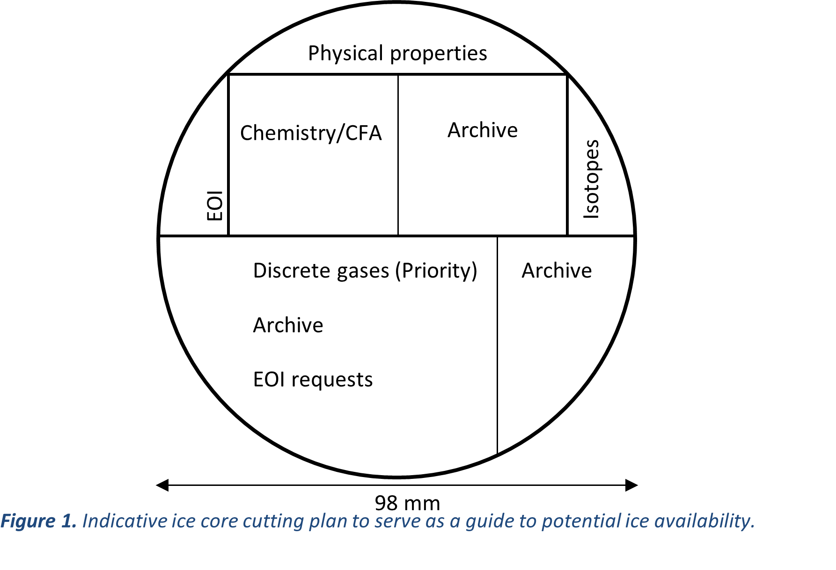

- Project Details
Project Title
Project leader
Samples requested
Duration of request

2. Project Team
Please complete for each project co-investigator. If you have more members, you can attach these separately.
Name
Email
Project Role
Affiliation
City
Country

Name
Email
Project Role
Affiliation
City
Country

Name
Email
Project Role
Affiliation
City
Country
Note: You must attach a current CV (up to 3 pages) for all Co-Investigators with relevant publication history.

3. Biosecurity
AA facility manager

Contact Phone
Contact Email
AA class
AA number
City/Institution
If you are completing any part of your work in Australia, please complete the following table.

4. Public Summary (max 250 words)
Provide a high-level summary of the project. Include relevant background information, intended broad science goals and basic overview of the plan to achieve this.

5. Research Objectives
Describe your science objectives. What are the key research questions you intend to answer, and how? Explain why this is the best approach to answer these questions.

6. Research Outcomes
What are the key outcomes for this research and who are the end users? What are the expected data products?

7. Project Timeline
Provide a clearly defined project timeline with milestones and deliverables for your project. Example deliverables could include method development, completion of testing, analytical targets, publications, presentation of data etc. The project timeline will be used to assess progress. Projects that require proof of concept or longer times to maturity are not disadvantaged, and we encourage realistic timelines over optimistic ones.

8. Funding
Indicate how you propose to fund this research. Projects may be granted ice access subject to funding approval within reasonable time frames. Please note that there is no commitment of AAD funding support for EOI projects.

9. Sample Plan
Provide details of your sample process and requirements. Include detail on how you plan to prepare your samples, required volumes, susceptibility to contaminants etc. Indicate your ideal and minimal sample requirements including any margin for decontamination. Provide details on how frequently you would like to sample the core and any specific time periods of interest. We cannot guarantee availability, so flexibility is encouraged. If you have any special handling requirements for sampling, please let us know – we may not be able to accommodate all requests. Make clear what you expect the MYIC team to do (e.g. collecting or cutting samples on your behalf) and what you will do. Projects that minimise time and resource demands on the MYIC project will be more straightforward to support.
Complete the summary table as best as possible. Refer to the cutting diagram for guidance on ice core dimensions and indicative sample pieces that may be available. These pieces are labelled EOI. We will assist you with determining reasonable ice sample targets. Entire core cross-sections are unlikely to be available beyond the near surface.
 | Preferred | Minimal
Sample type | e.g. discrete, CFA, surface snow etc.
Time intervals of interest | e.g. 0 – 2000 years, LGM, Holocene, glacial cycles etc. | Any
Temporal and/or physical sample resolution or frequency. | e.g. continuous at centennial or millennial resolution, 1 sample every 10 metres, 1 sample every 1000 years etc. | Any
Sample size (physical) | e.g. 10 x 3 cm piece of ice. | Minimal size needed
Sample volume | e.g. 10 ml clean sample, 50 ml sample, 200 g ice piece etc.
Test ice required? | Indicate if you require ice from the MYIC site or other cores for methods testing

Declaration
By making this request I agree:
- Access to samples is contingent on agreeing to conditions imposed by the AAD through consultation with MYIC Work Package or Science Steering Committee (e.g. submission of progress reports, satisfactory methods testing).
- Submit an annual summary of progress to the relevant Work Package. Continued sample access is contingent on satisfactory progress against milestones outlined in your project timeline. Projects may be asked to return any unused samples to the AAD at the proponent’s expense.
- To acknowledge AAD in any publications or outreach activity associated with this sample use and submit details of publications arising from MYIC samples to the AAD publication portal www.antarctica.gov.au/about-us/publications. Publications should acknowledge AAD contribution by including the following text “This project acknowledges the contribution of the Australian Antarctic Division’s Million Year Ice Core project AAS 4632”.
- To lodge all data resulting from the use of the samples with the Australian Antarctic Data Centre. This includes published data at the time of publication, and any further unpublished data within 3 years of the conclusion of your receiving MYIC samples. Projects should adhere to FAIR data principles https://www.go-fair.org/fair-principles/, making their data Findable, Accessible, Interoperable, and Reuseable.
- Adhere to any sample management instructions or protocols specified by the AAD including conditions associated with access, transport, use and disposal of samples. This includes following all biosecurity permit conditions within Australia.
- Provision of samples represents a collaboration with AAD/MYIC scientists noting the project’s substantial financial and intellectual investments in drilling, ice transport, sample processing, storage, and dating. Authorship of MYIC/AAD scientists on resulting publications is not assumed, but fair opportunity for scientific involvement and co-authorship of relevant project scientists is expected.
- The AAD respects your right to privacy and complies with the Privacy Act 1988 (Cth) (Privacy Act) in relation to handling personal information supplied in this form. Personal information will be used only for purposes related to the management, assessment, evaluation and monitoring activities associated with your sample request. You can review the Privacy Policy here www.dcceew.gov.au/about/commitment/privacy.
Project Leader Details
Name:
Signature:
Institution:
Date:

Checklist - Please make sure you have completed the following items and included them with your submission
Public summary
Project team details (including CV and recent publications)
Biosecurity information (if conducting work in Australia)
Research objectives
Research outcomes
Project timeline
Sample plan
Read and understood your obligations and signed the declaration acknowledging this
MYIC project approvals
Work Package leader | Antarctic Climate Program (ACP) Leader
Date: | Date:
Science Steering Committee | MYIC Chief Investigator
Date: | Date:

