Commonwealth Coat of Arms
Australian Government Department of Climate Change, Energy, the Environment and Water, Australian Antarctic Division.

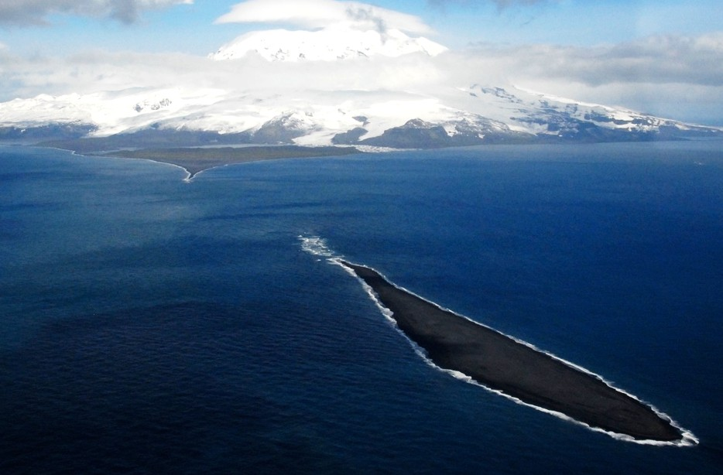

Conservation values in the marine environment surrounding Heard Island and McDonald Islands

### Dirk Welsford, Tim Lamb, Cara Masere and Michael Sumner

Environment Information Australia and the Australian Antarctic Division, DCCEEW

© Commonwealth of Australia 2024

**Ownership of intellectual property rights**

Unless otherwise noted, copyright (and any other intellectual property rights) in this publication is owned by the Commonwealth of Australia (referred to as the Commonwealth).

**Creative Commons licence**

All material in this publication is licensed under a Creative Commons Attribution 4.0 International Licence except content supplied by third parties, logos and the Commonwealth Coat of Arms.

Inquiries about the licence and any use of this document should be emailed to [copyright@dcceew.gov.au.](mailto:copyright@dcceew.gov.au)

Creative Commons logo.

**Cataloguing data**

This publication (and any material sourced from it) should be attributed as: Welsford, D., Lamb, T., Masere, C., and Sumner,

M. (2024) Conservation values in the marine environment surrounding Heard Island and the McDonald Islands, Department of Climate Change, Energy, the Environment and Water, Canberra, March CC BY 4.0.

This publication is available at dcceew.gov.au/publications.

Department of Climate Change, Energy, the Environment and Water GPO Box 3090 Canberra ACT 2601

Telephone 1800 900 090 Web dcceew.gov.au

**Acknowledgements**

The authors thank Rhonda Bartley, Elanor Bell, Jaimie Cleeland , Julie McInnes, Richard Mazurek, Patricia Miloslavich, Ben Raymond, Aleks Terauds, John van den Hoff and Barbara Wienecke from the Australian Antarctic Division for their assistance in preparing this report. We also sincerely appreciate the input by the Heard Island and McDonald Island Marine Reserve stakeholder group.

**Acknowledgement of Country**

Our department recognises the First Peoples of this nation and their ongoing connection to culture and country. We acknowledge Aboriginal and Torres Strait Islander Peoples as the Traditional Owners, Custodians and Lore Keepers of the world's oldest living culture and pay respects to their Elders past, and present. The authors note most of this work was conducted on the traditional country of the muwinina people. Respecting the practice of the palawa, traditional placenames in lutrawita/Tasmania are not capitalised.

Cover image: Elephant Spit, Heard Island, 2008 © Gary Miller/AAD

# Contents

Summary v

Introduction 1

1 Conservation values in the marine environment surrounding Heard Island and McDonald Islands 4

* 1. Information and methods used 4
  2. Physical environment 4
  3. Biology and ecology 7
  4. Representation of conservation values in the HIMI Marine Reserve 17

2 Pressures on the HIMI marine ecosystem 21

* 1. Direct human activities 21
  2. Climate change 23
  3. Marine pollution 23
  4. Invasive species and species range extensions 24

Conclusion 25

Appendix A: Vertebrate species recorded in the HIMI EEZ 26

References 32

Tables

Table 1 Estimated representation of demersal fish assemblages inside the HIMI Marine Reserve, based on the analysis of areal extent of Regions of Common Profile (RCP) by Hill et al. (2017).. SST = sea surface temperature, Chl-a = Chlorophyll a. 18

Table 2 Estimated representation of common habitat-forming benthic invertebrates in the HIMI Marine Reserve. Adapted from Welsford et al. (2014) and Hibberd et al. (2014) 19

Table 3 Estimated representation of globally important habitat for seabirds and seals in the HIMI Marine Reserve at more than 75 percent importance level. NA= no habitat of more than 75 percent global importance present in HIMI EEZ. 20

Figures

Figure 1 Heard Island and McDonald Islands in relation to Australia and Antarctica 2

Figure 2 The Northern and Central Kerguelen Plateau, showing the outer limits of Australian and French Exclusive Economic Zone boundaries, and boundaries of the Convention for the Conservation of Antarctic Marine Living Resources (CCAMLR) management areas. The Southern Indian Ocean Fisheries Agreement (SIOFA) applies outside the CCAMLR area north of latitude 55°S. Also shown are submarine features and the approximate positions of major oceanographic fronts in the region.

Bathymetry from GEBCO (2019) 3

Figure 3 Geomorphic units in the HIMI EEZ identified in Welsford et al*.* (2014), adapted from Brolsma (2012), characterised by depth, slope and broad-scale substratum types. The boundaries of the HIMI Marine Reserve and Conservation zone prior to 2014 are shown in grey. Red points indicate benthic sampling locations analysed in Welsford et al. (2014), with location of samples with high diversity of undescribed pycnogonids indicated by a black oval on the plateau northwest of Heard Island. 5

Figure 4 Geomorphic features in the HIMI EEZ identified by Post (2016). Other data sources used include Alcock et al. (2020); Commonwealth of Australia (2023) and GEBCO Compilation Group (2023). 6

Figure 5 The Exclusive Economic Zone at Heard Island and McDonald Islands, showing the location of the Marine Reserve, submarine features referred to in this report, approximate direction of mass water flows across the region based on van Wijk et al. (2010) and Park et al. (2014). 7

Figure 6 Suomi National Polar-orbiting Partnership Visible Infrared Imager Radiometry Suite (VIIRS) image showing chlorophyll rich (blue/green) phytoplankton blooming in waters enriched by iron over the Kerguelen Plateau, 21 November 2015 (NASA Ocean Biology Processing Group, 2015). HI= Approximate position of Heard Island, IK= Îles Kerguelen (the Kerguelen Islands) 8

Figure 7 Predicted distribution of biomass (gm-2) of the sixteen most abundant habitat forming benthic taxa at HIMI. Adapted from (Hibberd et al., 2014) 9

Figure 8 Regions of Common Profile (RCPs), areas with statistically distinct diversity and abundance of common demersal fish species, across the Kerguelen Plateau (from Hill et al., 2017) 12

Figure 9 Estimation of habitat importance of the HIMI EEZ for seabirds using tagging and tracking data for individuals recording entering the HIMI EEZ, adapted from Hindell et al. (2020) and Ropert- Coudert et al. (2020). A=King penguins, B=Macaroni penguins, C=Black-browed albatross, D=Light- mantled albatross, E=Wandering albatross. Magenta line indicates margin of 75 percent global habitat importance 14

Figure 10 Estimation of habitat importance of the HIMI EEZ for southern elephant seals (A) and Antarctic fur seals (B) using tagging and tracking data for individuals that used the HIMI EEZ, adapted percent global habitat importance. 16

# Summary

Heard Island and McDonald Islands (HIMI) are an external Territory of Australia, located approximately 4000 kilometres southwest of Australia in the southern Indian Ocean.

One of the world’s largest highly protected IUCN category 1A marine reserves the *Heard Island and McDonald Islands Marine Reserve* was established by Australia in the waters surrounding HIMI in 2002. The reserve recognised the significant conservation values that exist in the sub-Antarctic region, including large numbers of penguins, seals and flying seabirds that forage and breed in the area, and the diverse marine communities that live on the submarine plateau and banks near the islands.

This report summarises currently available scientific knowledge on the status of conservation values in the marine environment around HIMI, and the threats posed by climate change, pollution, fishing and invasive species. It concludes that the Marine Reserve includes important representation of many of the conservation values identified. However, recent data and analyses indicate that management of areas that support deep sea fish assemblages – including skates, high diversity benthic invertebrate assemblages, such as endemic sea spiders, unique seamounts, and foraging areas for albatross and macaroni penguins – should be further evaluated to ensure they provide adequate protection.

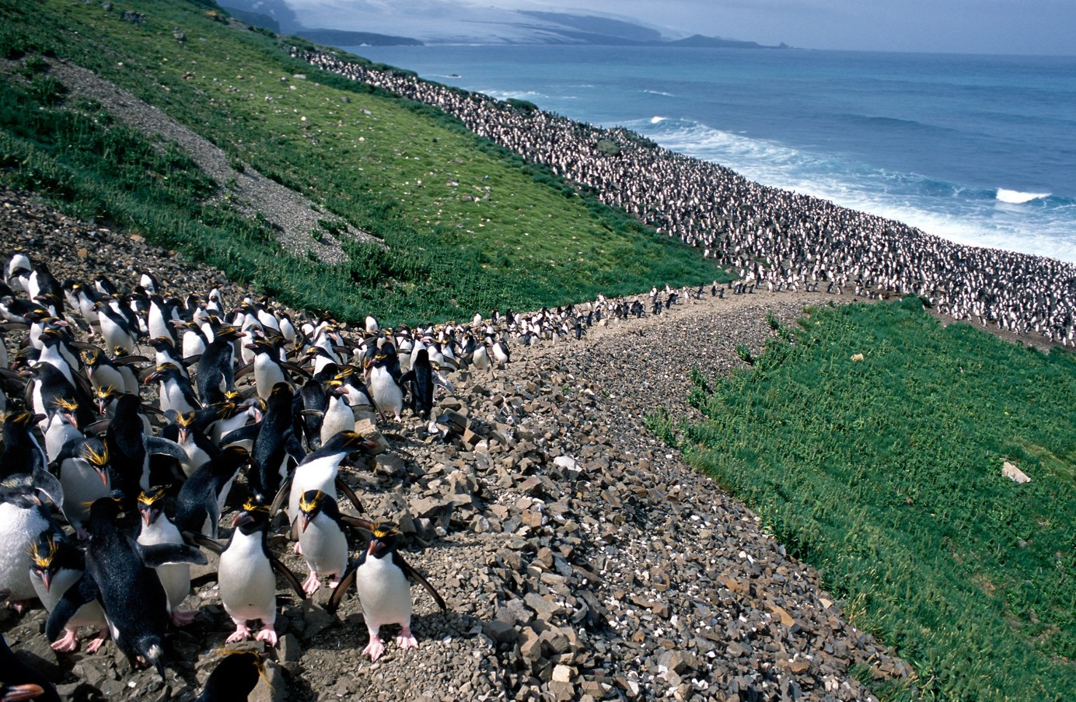

Image: Macaroni penguins, Heard Island, 2004 © Karl Rollings/AAD

# Introduction

Heard Island and McDonald Islands (HIMI) are an archipelago of seven islands approximately 4000 km southwest of continental Australia (Figure 1). These islands are an external Territory of Australia. Australia’s maritime jurisdiction at HIMI generally extends to the outer limit of the 200 nautical mile (nm) Exclusive Economic Zone (EEZ) around the islands. The HIMI EEZ abuts the French EEZ around the Îles Kerguelen (Kerguelen Islands). Australia has a treaty with France that covers matters of mutual interest concerning the Kerguelen Plateau (Weragoda et al., 2019).a The HIMI EEZ sits within the Area of the Convention on the Conservation of Antarctic Marine Living Resources (CAMLR Convention) (Figure 2).

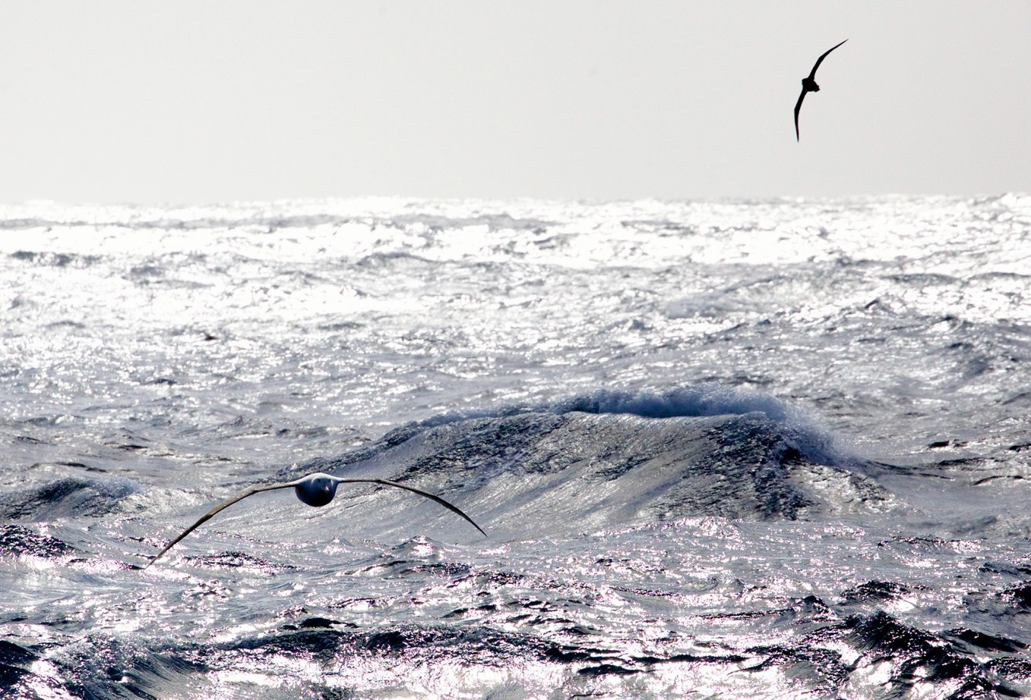

Image: Albatross in flight near Heard Island, 2016 © Pete Harmsen/AAD

a *Agreement on Cooperative Enforcement of Fisheries Laws between the Government of Australia and the Government of the French Republic in the Maritime Areas Adjacent to the French Southern and Antarctic Territories, Heard Island and the McDonald Islands* [http://www.austlii.edu.au/au/other/dfat/treaties/ATS/2011/1.html.](http://www.austlii.edu.au/au/other/dfat/treaties/ATS/2011/1.html) Accessed 12 September 2023.

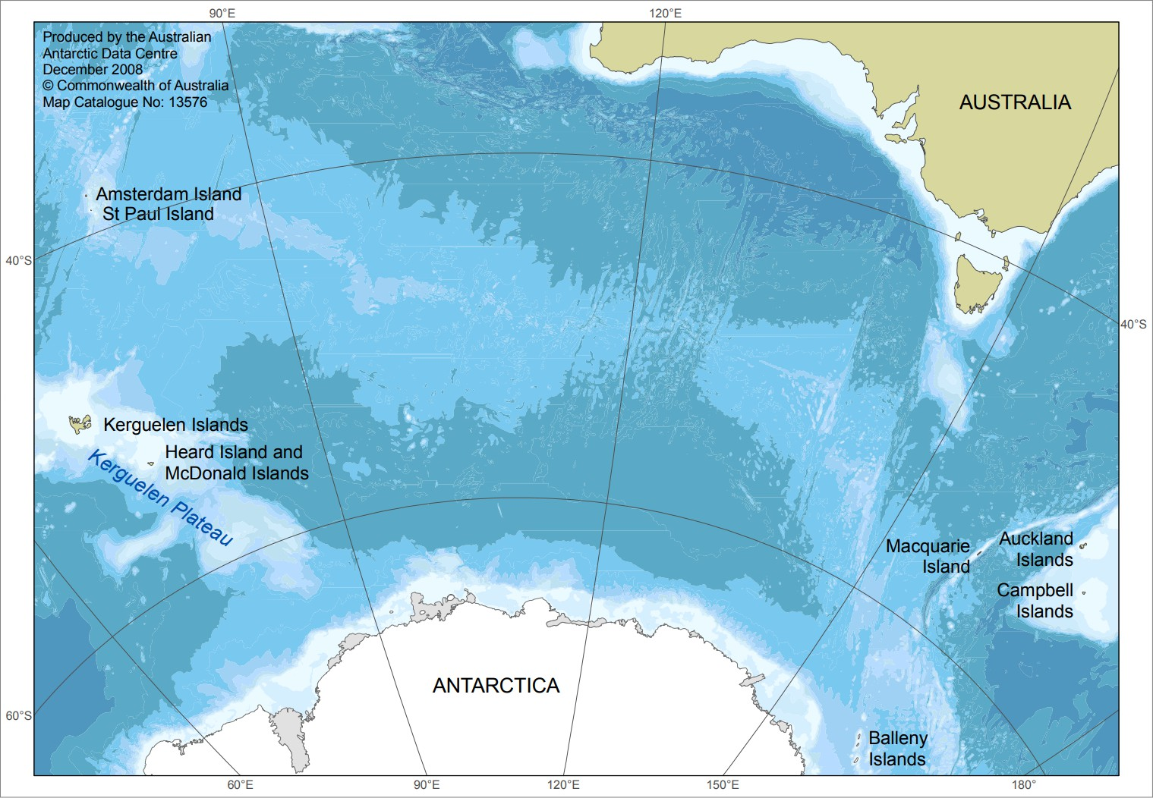

Figure 1 Heard Island and McDonald Islands in relation to Australia and Antarctica.

In recognition of the unique conservation values of the marine environment at HIMI, a marine reserve was established in 2002. The reserve was expanded from 65,000 square kilometres to 71,200 square kilometres in 2014, concurrent with the making of a new management plan (Commonwealth of Australia, 2014).

A history of the management of the marine environment at HIMI is summarised in Welsford et al. (2011), Commonwealth of Australia (2014) and Brooks et al. (2019). New research available since the last in-depth review of the conservation values in this region, and the statutory requirement to update the current management plan (Commonwealth of Australia, 2014), provide an opportunity to review the state of knowledge on conservation values in the HIMI EEZ.

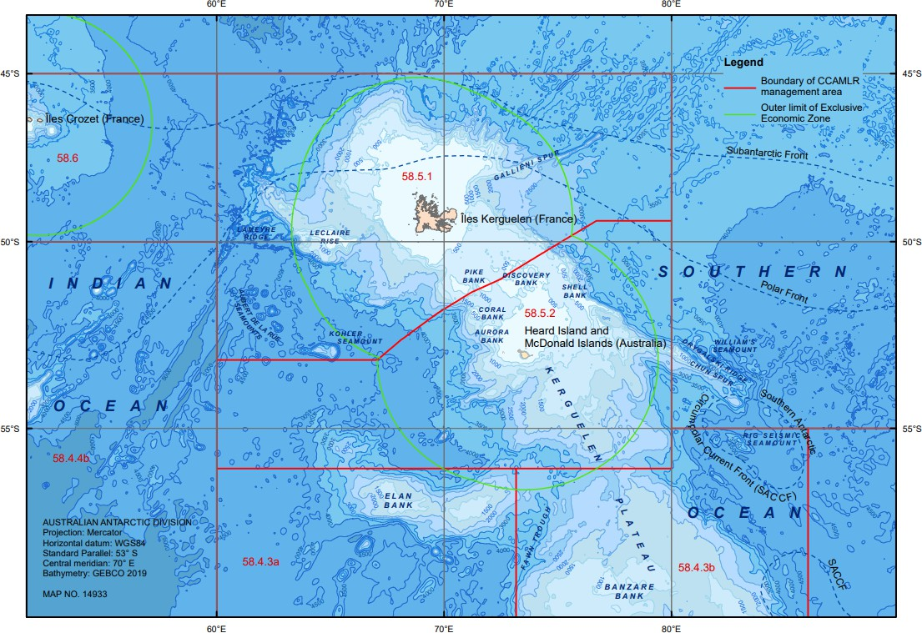

Figure 2 The Northern and Central Kerguelen Plateau, showing the outer limits of Australian and French Exclusive Economic Zone boundaries, and boundaries of the Convention for the Conservation of Antarctic Marine Living Resources (CCAMLR) management areas. The Southern Indian Ocean Fisheries Agreement (SIOFA) applies outside the CCAMLR area north of latitude 55°S. Also shown are submarine features and the approximate positions of major oceanographic fronts in the region. Bathymetry from GEBCO (2019).

# Conservation values in the marine environment surrounding Heard Island

## Information and methods used

This report draws on the published literature, data held by the Australian Antarctic Data Centreb and papers developed by the Australian Government, including contract reports and papers tabled to domestic and international forums such as the Scientific Committee to the Commission for the Conservation of Antarctic Marine Living Resources. Full citations, digital object identifiers or links to published materials are provided in the reference list. Where the Commonwealth of Australia is not the data owner, or privacy or confidentiality of information is protected by law, this is indicated, and the authors included in the reference list should be considered the first point for contact for data access.

## Physical environment

### Geomorphology

Heard Island and McDonald Islands are summits of volcanoes that emerge above the Kerguelen Plateau. This plateau is the largest submarine plateau in the southern hemisphere, estimated to have formed 115 million years ago (Wallace et al., 2002). The active volcanoes on Heard Island (Big Ben) and McDonald Islands are estimated to have emerged above the seafloor between 1,000,000 and 100,000 years ago (Duncan et al., 2016). Methane seeps have recently been discovered near Heard Island and may be a result of volcanic activity and/or accelerated decomposition of biological material in sediments due to geothermal energy (Spain et al., 2020).

High resolution bathymetry of the seafloor around Heard Island has been updated in 2011 (Beaman & O’Brien, 2011) and 2023 (Beaman, 2023) to incorporate single beam data from fishing vessels and multi-beam data from research voyages, including from the 2016 and 2020 voyages by the *RV Investigator* (Coffin et al., 2020)*.*

Characterisation of geomorphological features across the EEZ have been conducted by Brolsma (2012) (Figure 3) and Post (2016) (Figure 4). Their results are broadly similar, however, as the datasets, feature definitions and extents of these analyses differ, some uncertainty as to the exact extent and nature of geomorphic features still exists, particularly in deeper areas to the south and west of Heard Island.

b https://data.aad.gov.au/

The five discrete submarine banks rising less than 500 metres with gazetted names: Pike, Discovery, Aurora and Coral banks to the north and north-west of Heard Island; and Shell Bank to the east, which is separated from the plateau by a trough were confirmed by Brolsma (ibid.). Sediment types ranged from rocks and cobbles on the tops of the banks, to sand and finer muds and silts across the shallow and deep plateau. Uniquely on Shell Bank, deposits of white ‘shelly’ material are found on its top (Meyer et al., 2000). Brolsma (ibid.) also identified a chain of banks and seamounts that link to Williams Ridge which extends beyond the EEZ, and a steep southern slope incised by canyons running down to the deep slope south and west of Heard Island.

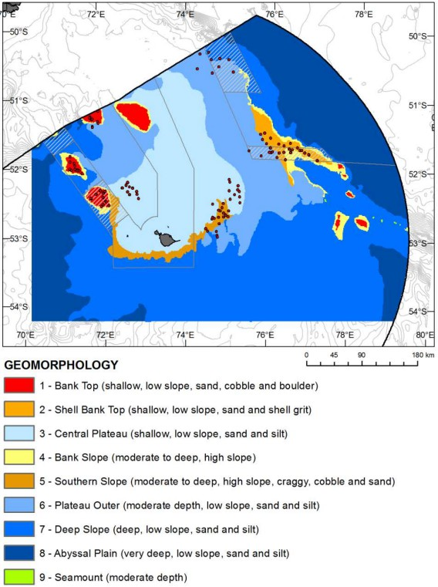

Figure 3 Geomorphic units in the HIMI EEZ identified in Welsford et al*.* (2014), adapted from Brolsma (2012), characterised by depth, slope and broad-scale substratum types. The boundaries of the HIMI Marine Reserve and Conservation zone prior to 2014 are shown in grey. Red points indicate benthic sampling locations analysed in Welsford et al. (2014), with location of samples with high diversity of undescribed pycnogonids indicated by a black oval on the plateau northwest of Heard Island.

Post (ibid.) identified similar plateau and plateau slope features and extent, however did not identify Coral or Shell Bank as a distinct feature, categorising the latter as part of the plateau joining Williams Ridge to the east. Post also identified a ridge contiguous with the plateau extending to the southwest of Heard Island, and an seamount emerging above the abyssal plain, also to the south west, beyond

the area considered by Brolsma (ibid.). Post (ibid.) also identifies a series of canyons running from the plateau down to the abyssal plain on the southern and western flanks of the plateau.

Both authors identify the deeper plateau/slopes joining the abyssal plains of the Enderby Basin to the west and the Australian-Antarctic Basin to the northeast. In the southeast, an extensive area of deeper plateau (approximately 1000 – 3000 metres) runs down to Fawn Trough, which separates the Central Kerguelen Plateau from BANZARE Bank.

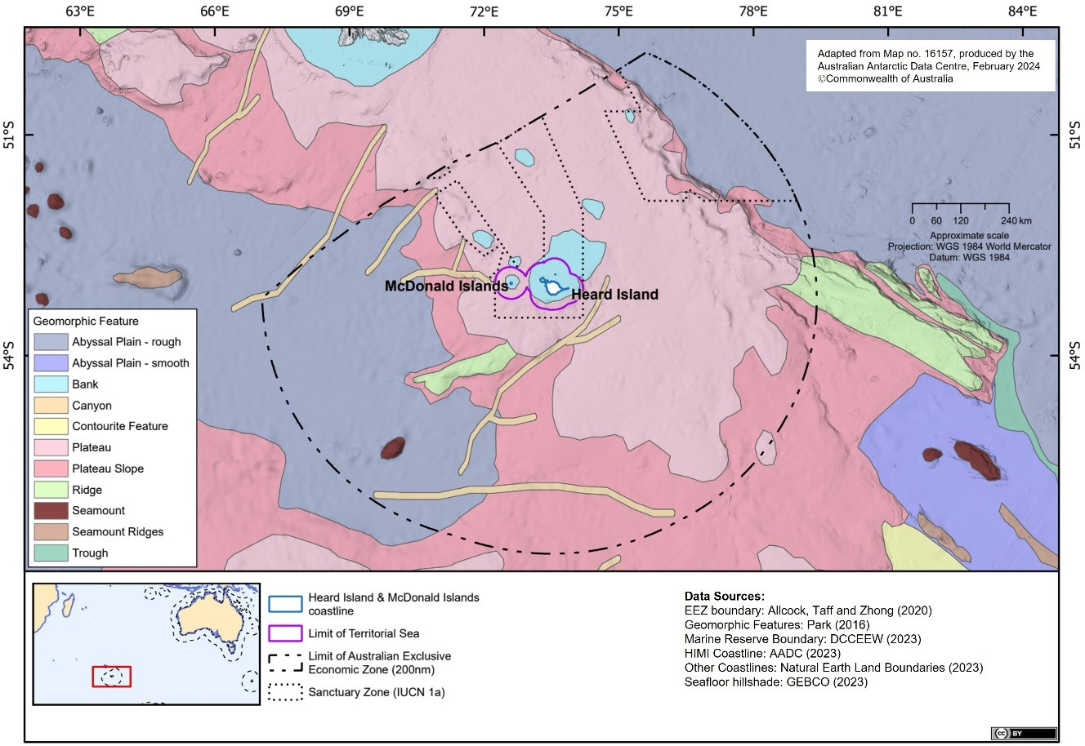

Figure 4 Geomorphic features in the HIMI EEZ identified by Post (2016). Other data sources used include Alcock et al. (2020); Commonwealth of Australia (2023) and GEBCO Compilation Group (2023).

### Oceanography and currents

The Kerguelen Plateau sits across the frontal systems that circulate west to east around Antarctica, including the Subantarctic Front (SAF), the Polar Front (PF) and the Southern Antarctic Circumpolar Current Front (SACCF) (Park et al., 2014). Strong tides can occur in the region and persistent strong winds can produce current speeds in excess of 20 metres per second. The west–east movement of water masses along these fronts drive flows along slope west and south of Heard Island, before accelerating and diverting to the northeast and splitting into further filaments around Shell Bank and Williams Ridge (Figure 5). This is believed to drive upwelling in the canyons south of Heard Island and Shell Bank, and the trough between Shell Bank and Gunnari Ridge (van Wijk et al., 2010). Surface waters are well mixed down to 180 metres, and can range from 2–4 degrees Celsius, while

deeper waters decline to temperatures as low as 0 degrees Celsius at depths in excess of 3000 metres.

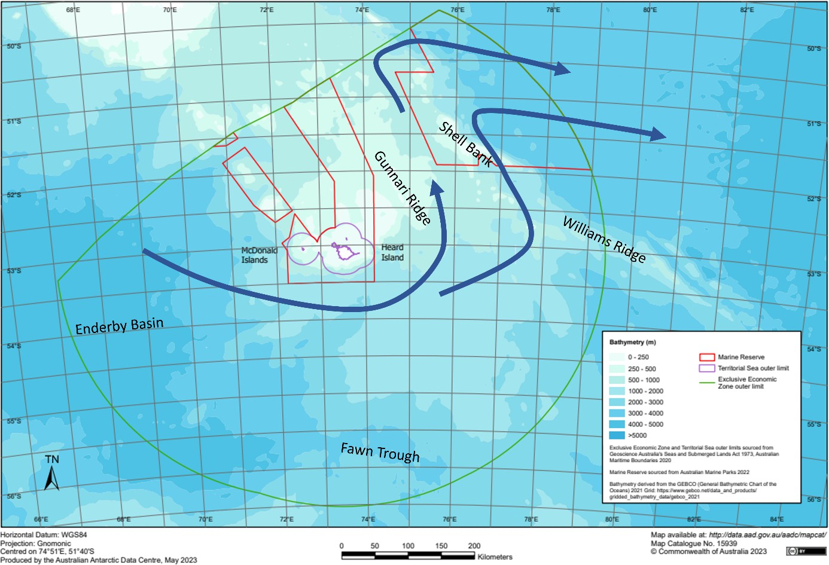

Figure 5 The Exclusive Economic Zone at Heard Island and McDonald Islands, showing the location of the Marine Reserve, submarine features referred to in this report, approximate direction of mass water flows across the region based on van Wijk et al. (2010) and Park et al. (2014).

## Biology and ecology

### Productivity

Primary productivity in the region originates from the activity of planktonic photosynthetic organisms. During late November through February, primary productivity is elevated over the plateau east and northeast of Heard Island and extends in a visible plume to the east of the island, extending beyond the EEZ (Figure 6) (Mongin et al., 2008). This enhanced productivity is believed to be a consequence of upwelling of nutrient-rich waters over the plateau and iron enrichment from the seafloor, glacial meltwater from Heard Island and hydrothermal activity at McDonald Islands (Holmes et al., 2019, 2020; Quéguiner et al., 2011; van der Merwe et al., 2019).

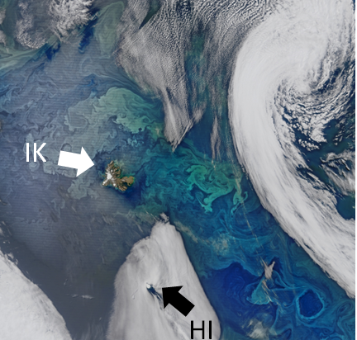

Figure 6 Suomi National Polar-orbiting Partnership Visible Infrared Imager Radiometry Suite (VIIRS) image showing chlorophyll rich (blue/green) phytoplankton blooming in waters enriched by iron over the Kerguelen Plateau, 21 November 2015 (NASA Ocean Biology Processing Group, 2015). HI= Approximate position of Heard Island, IK= Îles Kerguelen (the Kerguelen Islands).

### Pelagic and benthic invertebrates

While systematic sampling is sparse in this region, the pelagic invertebrate fauna in the HIMI EEZ is apparently broadly similar to those found in other sub-Antarctic waters, and tends to be linked to depth, primary productivity and the position of frontal zones (De Broyer et al., 2014). Summer biomass of zooplankton is concentrated in the epipelagic zone (0–300 metres) in areas of high primary productivity and includes chaetognaths, euphausiids (*Euphausia valentinii* over the plateau and slope, and *E. triacantha* and *E. frigida* to the south over the deep plateau), amphipods dominated by *Themisto gaudichaudii*, copepods such as *Rhincalanus gigas* and salps such as *Salpa thompsoni* (B. P. V. Hunt et al., 2011; B. P. V Hunt & Swadling, 2021). These species are important prey for larger pelagic invertebrates such as squids, larval and mesopelagic fish, and penguins (Cherel & Duhamel, 2003; Deagle et al., 2007; Klages et al., 1990).

The majority of the knowledge of the pelagic cephalopod fauna specifically surrounding HIMI, or more broadly over the Kerguelen Plateau, is derived from dietary studies. This in itself is a strong indication of their importance as prey species for larger fishes, and marine birds and mammals in the region. Some of the larger squids and octopods have also been recorded as bycatch from trawling.

The cephalopod fauna around HIMI is diverse, with onychoteuthid (e.g. *Onykia ingens*, *Filippovia*

*knipovitchi* and *Kondakovia longimana*), gonatid (e.g. *Gonatus antarcticus*), cranchiid (e.g. *Galiteuthis glacialis*), ommastrephid (e.g. *Martialia hyadesi* and *Todarodes* spp.), neoteuthid (e.g. *Alluroteuthis antarcticus*), histioteuthid (e.g. *Histioteuthis eltaninae*) and mastigoteuthid (e.g. *Mastigoteuthis* spp.) squids reported (Cherel et al., 2004; Cherel & Duhamel, 2004; Moore et al., 1998; Slip, 1995).

The benthic fauna at Heard Island is diverse, with over 500 distinct invertebrate taxa identified in bottom samples from the banks, shallow plateau and slopes down to 1000 metres (Hibberd, 2014). Highest diversity is observed on the shallow plateau northwest of HIMI and on Shell Bank. Habitat modelling indicates that sessile habitat-forming groups such as sponges, corals, ascidians, serpulid worms, hydroids and bryozoans are concentrated on the tops of the banks to the north and northwest of HIMI, the shallow plateau northwest of HIMI and the banks and seamounts (*sensu* Brolsma 2012) or ridge (*sensu* Post 2016) between Shell Bank and Williams Ridge (Hibberd et al., 2014) (Figure 7).

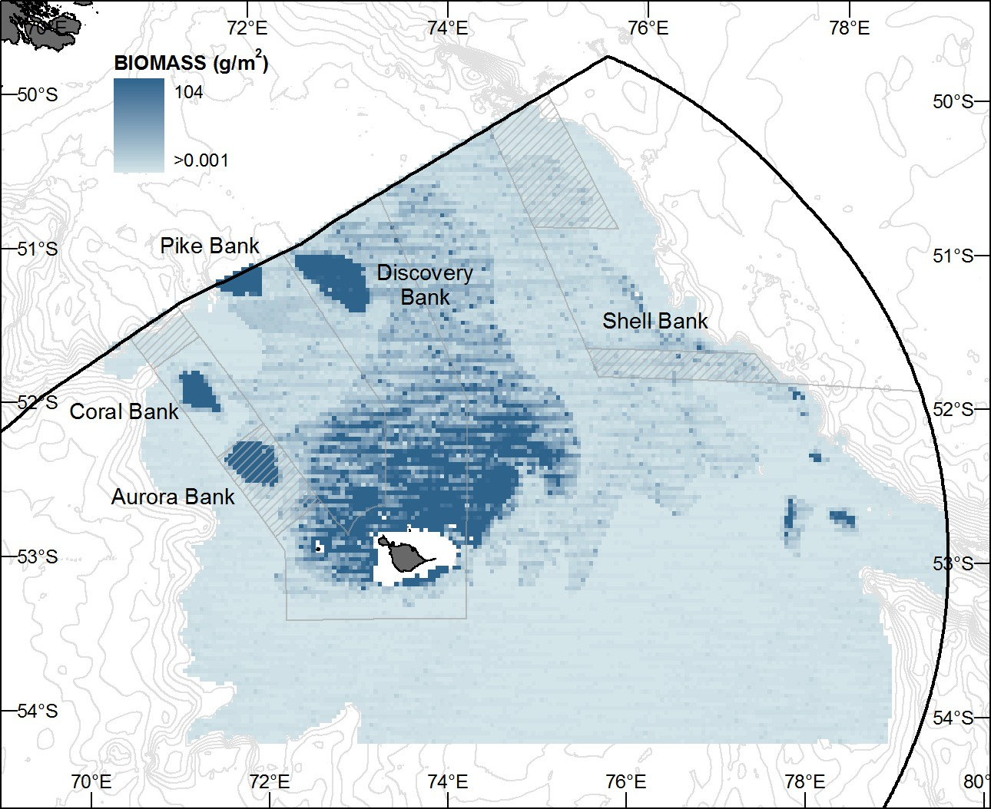

Figure 7 Predicted distribution of biomass (gm-2) of the sixteen most abundant habitat forming benthic taxa at HIMI. Adapted from (Hibberd et al., 2014).

The benthic fauna in the HIMI EEZ shows many species in common with the French EEZ around Îles Kerguelen (De Broyer et al., 2014). It is hypothesized that the Kerguelen Plateau forms a contact zone between the subantarctic bioregions of South America and the Southern Atlantic, via propagules eggs and larvae dispersed west to east on the prevailing currents, and the Antarctic where species

may move north from the Antarctic shelf via BANZARE Bank (Griffiths et al., 2009). However, despite these broad biogeographic patterns, endemism in the benthic fauna on the plateau at HIMI is likely due to the age and isolation of shallow benthic habitats, diversity of benthic habitats and the relatively poor dispersal characteristics of many sub-Antarctic taxa (De Broyer et al., 2014; Feral & Poulin, 2011; Griffiths et al., 2009). Hibberd (2014), for example, identified several undescribed morphotypes of holothurian (sea cucumber) which have subsequently been classified as five new species and one new genus (O’Loughlin et al., 2015). Several undescribed morphotypes of pycnogonid (sea spider) have been collected that are restricted to one bank or to the shallow western plateau sampling site approximately 60 kilometres northwest of Heard Island (Figure 3) and are also likely to be endemic (Munilla & Soler Membrives, 2009). Cryptic species have also been recently discovered in the region using molecular techniques (McLaughlin et al., 2023; Smith et al., 2011), and sampling of deeper habitats in the HIMI EEZ is limited, further contributing to current estimates of diversity being likely to be conservative.

### Fish

The majority of information relating to the fishes at HIMI result from research conducted during Australian, French and Russian research cruises in the latter half of the 20th century ( e.g. Williams & de la Mare, 1995), and data collected by observers from commercial fishing activities (Lamb et al., 2006). Over 90 different species of fishes from 38 families have been recorded from waters within the EEZ around HIMI (Table A 1).

Due to its position on the Kerguelen Plateau, the fish fauna recorded at HIMI almost completely overlaps that described in the French EEZ around the Kerguelen Islands. It also shows broad affinities with the fish fauna of other sub-Antarctic islands in the Indian Ocean sector of the Southern Ocean, and with Macquarie Island and the islands of the southern Atlantic (De Broyer et al., 2014; Duhamel et al., 2005; Gon & Heemstra, 1990). However, as HIMI lies further south than other sub-Antarctic islands in the Indian Ocean sector, below the Subantarctic and Polar fronts, there is some evidence for overlap between sub-Antarctic and Antarctic fauna around the islands. For example, the Antarctic toothfish (*Dissostichus mawsoni*), which is a large predator usually found on the shelf and slopes around Antarctica, is occasionally captured during commercial fishing at HIMI (Maschette, Wotherspoon, et al., 2023).

In common with other regions of the Southern Ocean, notothenioid fishes (including members of the Notothenidae, Channichthyidae, Bathydraconidae and Harpagiferidae) are the single most diverse group in nearshore and shallow plateau waters (less than 500 metres). At least 15 species are confirmed to occur at HIMI, including the triangular rockcod (*Gobionotothen acuta*) and the unicorn icefish (*Channichthys rhinoceratus*), which are endemic to the nearshore areas of the Kerguelen Plateau, and the spiny plunderfish (*Harpagifer spinosus*) which is found only on the Kerguelen Plateau and at Crozet Islands (Gon & Heemstra, 1990). Four species of notothenioid are also the most abundant fishes on the plateau and banks around HIMI, with the Patagonian toothfish (*Dissostichus eleginoides*), mackerel icefish (*Champsocephalus gunnari*), grey rock cod (*Lepidonotothen squamifrons*) and unicorn icefish historically widespread and locally abundant on the plateau and banks around HIMI and Iles Kerguelen (Lamb et al., 2006; Williams & de la Mare, 1995). Due to unregulated overfishing prior to the establishment of the Australian EEZ, and a relatively restricted distribution (Maschette, 2015; Maschette et al., 2015), *L. squamifrons* has

been identified as the species most at risk from the impacts of fishing at HIMI (Sporcic et al., 2018).

Icefishes (channichthyids) have a genetic mutation that means they have very little haemoglobin in their blood stream (Corliss et al., 2019), making them potentially vulnerable to habitat contraction with declines in dissolved oxygen associated with warming of the ocean (Constable et al., 2014).

However while mackerel icefish abundance has not returned to historical highs on the northern Kerguelen Plateau, abundance of unicorn icefish and persistence of very large individuals of mackerel icefish indicate the response of species to changing environmental conditions is complex (Duhamel & Hautecoeur, 2009; Maschette & Welsford, 2019).

Seven species of chondrichthyans have been recorded in the area. Two species of skates (including *Bathyraja eatonii*, which is endemic to the Kerguelen Plateau) are relatively common inshore and on the shallow plateau (Nowara et al., 2017). On the deeper slopes, macrourids (*Macrourus* spp.) are a common bycatch in longlining targeting toothfish, along with *B. irrasa* which is endemic to Kerguelen and listed as vulnerable by the International Union for Conservation of Nature and Natural Resources (IUCN) due to declining catch rates in the French EEZ (Dulvy et al., 2020). The largest fish species occurring at HIMI is the sleeper shark (*Somniosus antarcticus*), individuals of which are occasionally captured in demersal trawls and on longlines targeting toothfish (Welsford & Lamb, 2013). The porbeagle shark, *Lamna nasus*, which is listed by the IUCN as vulnerable (Rigby et al., 2019) and is listed as a migratory species under the *Environmental Protection and Biodiversity Conservation Act 1999c* (the EPBC Act 1999), (Department of the Environment, 2023d) is also occasionally incidentally caught (bycatch) in the longline fishery (Australian Fisheries Management Authority, 2023; Welsford & Lamb, 2013).

Modelling of fish assemblages, based on samples collected across the Kerguelen Plateau, identified seven distinct fish assemblages (Hill et al., 2017). This analysis also indicated that distinct fish species distributions and assemblages in locations are correlated with bottom depth, surface chlorophyll and sea surface temperature. The eastern and western shallow plateau and banks supported distinct assemblages including endemic notothenioids, whereas the deeper slopes contained more widespread species such as grenadiers (macrourids) (Figure 8).

Other demersal fish species are generally uncommon, with many of those recorded resulting from only a small number of specimens collected from research and commercial fishing. However, due to the lack of systematic sampling, particularly in the deeper areas of the plateau and the abyssal plain, and the fact that it is only relatively recently that the taxonomy of fishes in the Southern Ocean has received detailed study, it is likely that more species, particularly in families adapted to these depths such as the Liparidae (snail fishes), would occur in the deeper (more than 3000 metres) areas of the HIMI EEZ (Duhamel & King, 2007).

c *Environmental Protection and Biodiversity Conservation Act 1999*, https://[www.legislation.gov.au/Series/C2004A00485](http://www.legislation.gov.au/Series/C2004A00485) accessed 27 October 2023

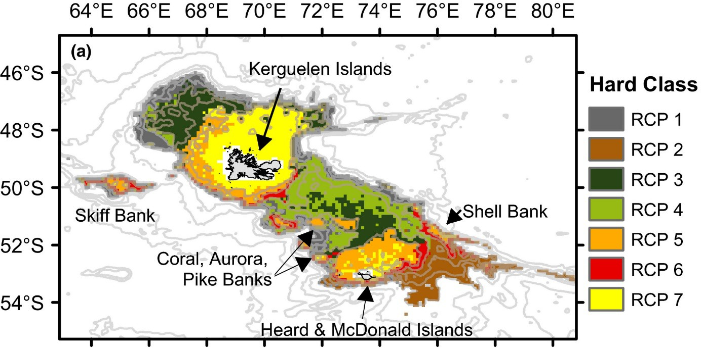

Figure 8 Regions of Common Profile (RCPs), areas with statistically distinct diversity and abundance of common demersal fish species, across the Kerguelen Plateau (from Hill et al., 2017).

The pelagic environment over the deeper plateau is dominated by myctophids (lanternfishes), with at least 19 species in six genera. Many of the species recorded at HIMI are widespread, with circumpolar distribution in the Southern Ocean (De Broyer et al., 2014; Gon & Heemstra, 1990). The north-south distribution of these species is frequently delineated by major frontal systems (Williams et al., 2011). Myctophids are a critical part of the offshore ecosystem. Through their *en masse* diurnal migrations over several hundred metres of the water column to feed on zooplankton, and as part of the diet of many marine predators (Scientific Committee on Antarctic Research, 2023) they have a significant role in nutrient and carbon cycling (Cotté et al., 2022).

### Seabirds

Of the more than 40 seabird species observed in the Indian Ocean sector of the Southern Ocean, 34 have been reported from Heard Island with 17 recorded as breeding there (Table A 2). Whether wandering albatrosses (*Diomedea exulans*) still breed on Heard Island is uncertain, as there has never been a substantial population of this species recorded.

Eleven of the seabird species that breed at Heard Island were also recorded breeding on the McDonald Islands during the 20th century. However, it is unknown how many species remain on the McDonald Islands, or how many may have recolonised the islands after a volcanic eruption in 2001.

The nearest landmass to HIMI is the Kerguelen Islands. These islands are approximately 440 km north of HIMI, within the flying distance of seabirds. There are 35 species of birds reported as breeding on the Kerguelen Islands: more than twice as many as at HIMI. Some species, for example the four penguin species, as well as black-browed (*Thalassarche melanophris*) and light-mantled albatross (*Phoebetria palpebrata*) are known to breed at both HIMI and the Kerguelen Islands.

Most seabirds that breed on Heard Island undertake breeding and chick rearing activities over spring and summer and spend the late autumn and winter at sea. King penguins are an exception to this pattern due to chick rearing taking 14–16 months, and based on species’ behaviour on other subantarctic island, gentoo penguins, giant petrels and some of the gull and tern species are likely to roost on the island over winter .

Observations of the diet of seabirds at HIMI is limited to the penguins that breed on the island collected last century, indicating they eat icefish, myctophids and other mesopelagic fish, squid, euphausiids and amphipods (Klages et al., 1990). Based on the observation from Iles Crozet and Kerguelen, albatrosses are likely to obtain their food from pelagic sources especially squid (Cherel et al., 2023). Other seabirds, such as the smaller petrels, consume crustaceans and small fish (Scientific Committee on Antarctic Research, 2023).

The foraging areas of these seabirds are highly variable and, in many cases, extend far beyond the HIMI EEZ. For example, the distances that king penguins travel to their foraging grounds depends upon the time of year, their breeding status and the stage of their breeding cycle, and foraging ranges can extend beyond the EEZ, even during chick-rearing, with albatross foraging along the Antarctic shelf (Moore et al., 1999; Wienecke & Robertson, 2006). Recent circumpolar and regional syntheses of satellite tagging and tracking data, including data collected in the HIMI region indicates that the waters east of Heard Island over Gunnari Ridge and Shell Bank, and the deeper trough between those features, were important foraging habitats for king and macaroni penguins, and black-browed and wandering albatross. It also identified that the shallow plateau, south and western slope and the deep waters over the abyssal plain to the west, southwest and northeast of HIMI are important habitat for black-browed and light-mantled albatrosses (Hindell et al., 2011; Patterson et al., 2016; Ropert-Coudert et al., 2020) (Figure 9).

A weighted estimate of the area of ecological significance for all predators for which tracking data were available indicated the deeper areas to the north-east and east of the plateau have the highest ecological significance overall. However it should be noted that tag and track data for HIMI seabirds is more than two decades old, and foraging distributions of seabirds such as King penguins are predicted to have shifted by tens of kilometres poleward over this timeframe (Cristofari et al., 2018; Péron et al., 2012)

Of the species that breed at HIMI, king and gentoo penguins, black-browed albatross, cape petrels (*Daption capense*) and Antarctic terns (*Sterna vittata*) are categorised as ‘least concern’ by the IUCN, while the remainder are classified as near-threatened or vulnerable (Table A 2). IUCN lists four species of seabirds that have been sighted in the HIMI EEZ as endangered: Barau’s petrel (*Pterodroma baraui*), the Atlantic yellow-nosed albatross (*Thalassarche chlororhynchos*), the yellow- nosed albatross (*T. carteri*), and the Amsterdam Island albatross (*Diomedea amsterdamensis*). Grey headed albatross (*T. chrysostoma*), shy albatross (*T. cauta*) and southern giant petrels (*Macronectes giganteus*) are also listed as endangered under the *EPBC Act 1999* (Department of the Environment, 2023a).

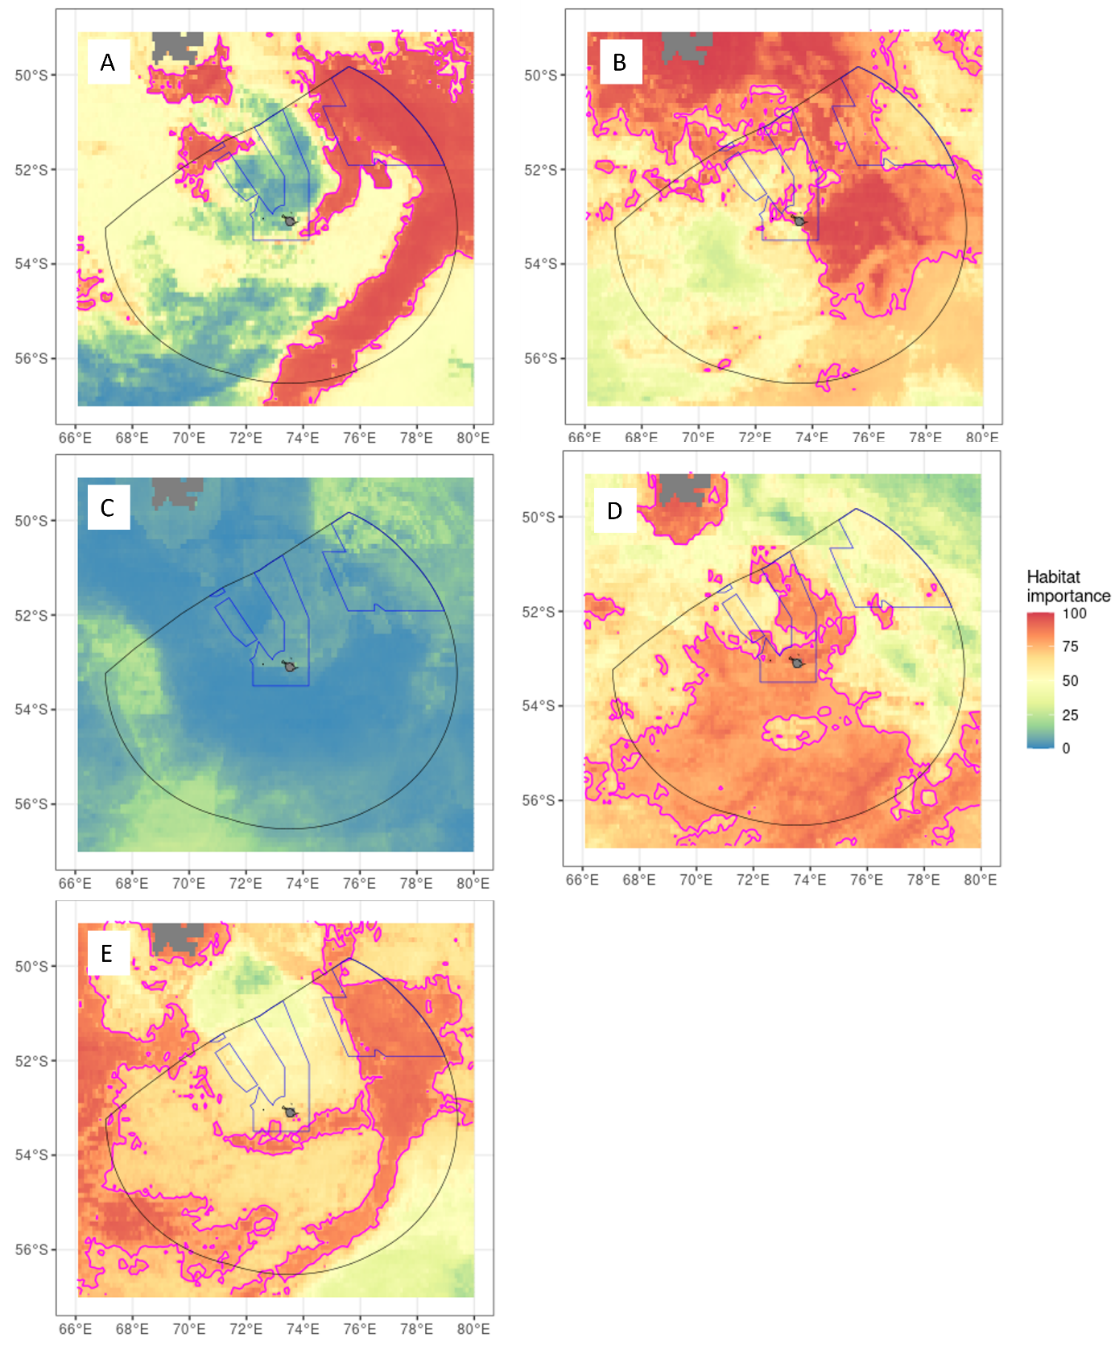

Figure 9 Estimation of habitat importance of the HIMI EEZ for seabirds using tagging and tracking data for individuals recording entering the HIMI EEZ, adapted from Hindell et al. (2020) and Ropert-Coudert et al. (2020). A=King penguins, B=Macaroni penguins, C=Black- browed albatross, D=Light-mantled albatross, E=Wandering albatross. Magenta line indicates margin of 75 percent global habitat importance.

### Marine Mammals

Seven species of seals (pinnipeds) have been recorded in the HIMI EEZ (Table A 3). Of these, the Antarctic fur seal (*Arctocephalus gazella*) and the southern elephant seal (*Mirounga leonina*) breed in significant numbers on Heard Island and forage in the HIMI EEZ.

Following sealing in the 19th century, Antarctic fur seals *Arctocephalus gazella* recolonised Heard Island in the 1960s. When last surveyed, in the summer of 2003/4, the *A. gazella* population on Heard Island numbered in the thousands and was estimated to be growing at 12–20 percent per annum, and small numbers of sub-Antarctic fur seal pups were also observed (Page et al., 2003). Antarctic fur seals are listed as marine species under the *EPBC Act 1999* (Department of the Environment, 2023b) and the IUCN considers this species as of least concern (Table A 3).

The population of southern elephant seals on HIMI persisted despite unregulated harvesting and was observed to fluctuate and then stabilise over the last half of the 20th century (Slip & Burton, 1999).

The last estimates collected indicated about 17,000 breeding females were ashore during the 1992 breeding season, estimated to represent approximately 30 percent of the total number of this species in the Indian Ocean (Slip & Burton, 1999). Southern elephant seals are listed as vulnerable under the EPBC Act (Department of the Environment, 2023e) and least concern by the IUCN (Table A 3).

Tracking and dietary studies indicate that female Antarctic fur seals breeding on Heard Island have a summer diet dominated by fish, in particular myctophids and mackerel icefish captured in the epipelagic zone (Goldsworthy et al., 2010). Female fur seals forage primarily over the shallow plateau to the east and northeast of Heard Island and over Gunnari Ridge. Male fur seals that haul out at Heard Island forage over a much larger range, including waters around the Kerguelen Islands and along the ice edge adjacent to East Antarctica (Patterson et al., 2016).

Southern elephant seals that breed at Heard Island are wide-ranging (Hindell et al., 2016). They forage for fish and cephalopods over the shallow plateau, banks and deeper slopes in the region, as well as making trips to the East Antarctic ice-edge, the continental shelf and nearshore coastal polynyas (Arce et al., 2022; Malpress et al., 2017). Elephant seals can dive to below 1500 metres and have been observed, by cameras attached to demersal longline targeting toothfish in the HIMI EEZ, interacting with hooked Patagonian toothfish at the seafloor (van den Hoff et al., 2017)

Analysis of tagging and tracking data indicates that the plateau slope and oceanic water east and northeast of Heard Island, including Shell Bank have highest importance for southern elephant seals and Antarctic fur seals, although the importance of the HIMI EEZ for the global Antarctic fur seal population was relatively low (Figure 10).

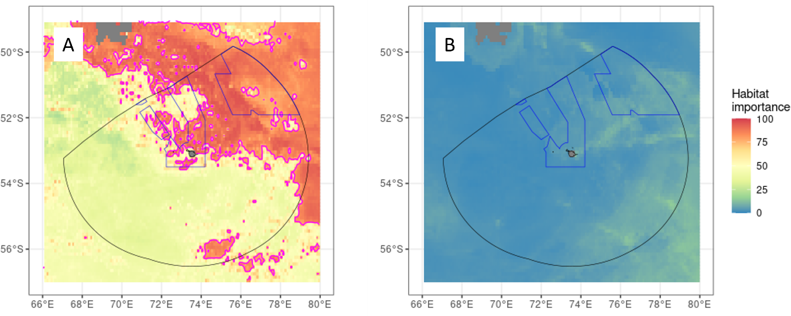

Figure 10 Estimation of habitat importance of the HIMI EEZ for southern elephant seals (A) and Antarctic fur seals (B) using tagging and tracking data for individuals that used the HIMI EEZ, adapted from Hindell et al. (2020) and Ropert-Coudert et al. (2020). Magenta line indicates margin of 75 percent global habitat importance.

Seventeen species of cetaceans including baleen whales, toothed whales and dolphins have been observed in the HIMI EEZ (Table A 3). Whaling data from the 20th century indicates that large baleen whales, including blue whales (*Balaenoptera musculus*), were uncommon at Heard Island and those observed are likely to be in transit between Antarctic feeding grounds and lower latitude breeding grounds (Branch et al., 2007). We were unable to find any published records of the southern right whale (*Eubalaena australis*) from the Heard Island EEZ. However, as they were historically hunted on the northern Kerguelen Plateau (Richards, 2009) they may transit the area as the move from southern feeding areas to northern breeding areas. Southern right whales are listed as endangered under the *EPBC Act 1999* (Department of the Environment, 2023c).

A recent survey noted that widely distributed species, such as fin whales (*Balaenoptera physalus*), Antarctic minke whales (*Balaenoptera bonaerensis*), hourglass dolphins (*Lagenorhynchus cruciger*) and long-finned pilot whales (*Globicephala* spp.), were the most common species observed, albeit in relatively small numbers (the highest species count was seven hourglass dolphins). Habitat modelling indicated a correlation between all species sightings and areas with higher primary productivity and slope bathymetry, predicting highest cetacean abundance and diversity over the slopes south and east of Heard Island (Todd & Williamson, 2022).

Sperm whale (*Physeter macrocephalus*) depredation of toothfish longlines, which is very prevalent in the French EEZ on the northern Kerguelen Plateau, has also become relatively common during autumn in the HIMI EEZ along the deeper slopes, as they migrate between summer feeding grounds further south and on the deeper slopes of northern Kerguelen Plateau (Tixier et al., 2019). Orcas (*Orcinus orca*) are also occasionally observed preying on toothfish, but their relationship to other populations in the region is unknown (Gasco et al., 2019). Feeding by baleen whales in the region is unknown. Orcas in the nearby French EEZ eat fish and squid, seals, penguins and whales (Reisinger et al., 2016), while other toothed whales primarily eat fish and squid (Fontaine et al., 2015). These taxa are likely to have a similar diet in the HIMI EEZ.

All cetaceans recorded in the HIMI EEZ are protected under the EPBC Act 1999 (Table A 3). In addition, Antarctic blue whales are listed as endangered, and sei (*Balaenoptera borealis*) and fin whales are listed as vulnerable. The IUCN lists orcas as data deficient, Antarctic minke whale as near threatened, fin and sperm whales as vulnerable and Antarctic blue whales as endangered. All other species are categorised as of least concern (Table A 3).

## Representation of conservation values in the HIMI Marine Reserve

The HIMI Marine Reserve encompasses the islands in their entirety and the marine waters as depicted in Figure 5. The entire reserve is given the highest protection under the EPBC Act – IUCN Category 1a Strict Nature Reserve. Due to all terrestrial components being captured within the reserve, this report only considers the representation of conservation values located in the marine environments in the EEZ.

### Representation of demersal fish assemblages

In their 2017 study, Hill et al. developed an approach for quantifying and mapping the distribution of demersal fish assemblages, focusing on the Kerguelen Plateau. Hill et al. called this approach ‘Regions of Common Profile’ (RCP). This approach identified seven distinct fish assemblages. This methodology allows for an estimate of how much of these regions are represented in the HIMI Marine Reserve by calculating the proportion of the total area of the regions of common profile inside the Marine Reserve (Table 1).

The seven regions are labelled from RCP 1 to RCP 7. All assemblages are represented in the HIMI Marine Reserve, with RCPs 3–7 having 31–54 percent of their area inside the Reserve.

The assemblages in RCPs 1 and 2 are less well represented at 26 percent and 12 percent in the Reserve, respectively. RCP 1 is characterised by a relatively species rich assemblage of grenadiers, blue antimora (*Antimora rostrata*) and relatively high abundance of all three skate species (*Bathyraja* spp.) in deeper slope waters. It is also the only RCP which includes the blue-eyed lantern shark (*Etmopterus viator*). RCP 2 is found at similar depths, but has lower temperature, productivity and species diversity.

Conservation values in the marine environment surrounding Heard Island and McDonald Islands

**Table 1 Estimated representation of demersal fish assemblages inside the HIMI Marine Reserve, based on the analysis of areal extent of Regions of Common Profile (RCP) by Hill et al. (2017). SST = sea surface temperature, Chl-a = Chlorophyll a.**

|  |  |  |
| --- | --- | --- |
| **RCP** | **Areal Representation in the HIMI Marine Reserve (%)** | **Characteristics of RCPd** |
| 1 | 26.2 | Deeper waters (more than 600 m), moderate mean SST (2–5 degrees Celsius), higher surface productivity (more than 1 mg.m-3 Chl-a). Assemblage characterised by relatively high abundance of grenadiers (*Macrourus* spp.), blue antimora (*Antimora rostrata*), skates (*Bathyraja* spp.). Only RCP with blue-eyed lantern shark (*Etmopterus viator*). |
| 2 | 12.2 | Deeper waters (more than 600 m), colder mean SST (less than 1 °C), lower surface productivity (less than 1 mg.m-3 Chl-a). Assemblage characterised by relatively high abundance of grenadiers and blue antimora. |
| 3 | 46.1 | Broad depth range (200–700 metres), warmer mean SST (more than 2 °C), higher primary productivity (more than 1 mg.m-3 Chl-a). High probability of occurrence of the unicorn icefish (*Channichthys rhinoceratus*), Eaton’s skate (*B. eatonii*) and grey rock cod (*Lepidonotothen squamifrons*). |
| 4 | 31.5 | Intermediate depth range (400–800 metres), moderate–low surface productivity (less than 1.5 mg.m-3 Chl-a). Assemblage characterised by relatively high abundance of grenadiers, skates, Antarctic armless flounder (*Mancopsetta maculata*), and snake mackerel (*Paradiplospinus gracilis*). |
| 5 | 52.0 | Shallower depth range (200 metres), moderate mean temperatures SST (2–5 degrees Celsius) and lower surface productivity (less than 1 mg.m-3 Chl-a). High probability of occurrence of unicorn icefish and mackerel icefish (*Champsocephalus gunnari*). |
| 6 | 45.2 | Broad depth range (200–700 metres), colder mean SST (less than 2 °C), lower primary productivity (less than 1 mg.m-3 Chl-a). High probability of occurrence of the unicorn icefish (*Channichthys rhinoceratus*) and grey rock cod (*Lepidonotothen squamifrons*). |
| 7 | 53.5 | Shallower depth range (200 metres), moderate mean temperatures SST (2–5 degrees Celsius) and higher surface productivity (less than 1 mg.m-3 Chl-a). High probability of occurrence of mackerel icefish. |

d Note Patagonian toothfish (*Dissostichus eleginoides*) were in relatively high abundance across all assemblages.

Department of Climate Change, Energy, the Environment and Water 18

### Benthic invertebrates

Sampling and modelling of benthic invertebrates at HIMI (Welsford *et al*. 2014, Hibberd *et al*. 2014) indicates that 16–70 percent of the estimated biomass of common habitat-forming taxa are represented in the Marine Reserve (Table 2. Taxa associated with the shallow plateau and bank tops, such as sponges and pterobranchs, are best represented due to the inclusion of Coral, Aurora and Discovery banks inside the HIMI Marine Reserve. Taxa that are less well represented include basket stars (euryalids) that were most common in the deeper plateau margin and upper slope areas, and stony corals (scleractinians) which were most common on the shallow plateau to the northeast and northwest of Heard Island.

**Table 2. Estimated representation of common habitat-forming benthic invertebrates in the HIMI Marine Reserve. Adapted from Welsford et al. (2014) and Hibberd et al. (2014).**

|  |  |
| --- | --- |
| **Taxon (common name)** | **Representation of estimated biomass in the HIMI Marine Reserve (percent)** |
| Alcyonaria (soft corals) | 42 |
| Actinaria (anemones) | 40 |
| Bryozoa | 56 |
| Cirripedia (stalked barnacles) | 47 |
| Scleractinia (stony corals) | 33 |
| Echinoidae (sea urchins) | 50 |
| Euryalidae (basket stars) | 16 |
| Gorgonacea (gorgonian corals) | 50 |
| Hydrozoa | 55 |
| Demospongia (sponges) | 70 |
| Pterobranchia | 70 |
| Ascideacea (sea squirts) | 50 |
| Serpulidae (tube worms) | 51 |

It was also noted in Hibberd et al. (2014) that the ‘Western Plateau’ site, while predicted to have moderate levels of biomass of habitat-forming benthic invertebrates and affinities with other parts of the southern plateau, was distinct from other assemblages and contained species that were not present at locations sampled in the Marine Reserve.

### Seabirds and mammals

Using a threshold of 75 percent or greater global importance from Hindell et al. 2020 and Ropert-Coudert et al. 2020, between 11 percent and 39 percent of globally important habitat for seals and seabirds is estimated to be represented in the HIMI Marine Reserve. The inclusion of Shell Bank in the Marine Reserve makes a substantial contribution to representation of important habitat for

southern elephant seals, and king penguins, and to a lesser extent macaroni penguins. Light-mantled albatross habitat was least well represented because the Marine Reserve does not extend over deep waters to the south and southeast of Heard Island that are predicted to be important to that species. Using the criterion of 75 percent or greater, no globally important habitat for Antarctic fur seals or black-browed albatross was identified in the HIMI EEZ.

**Table 3 Estimated representation of globally important habitat for seabirds and seals in the HIMI Marine Reserve at more than 75 percent importance level. NA= no habitat of more than 75 percent global importance present in HIMI EEZ.**

|  |  |
| --- | --- |
| **Species** | **Representation of area of habitat importance**  **More than 75 percent in the HIMI Marine Reserve (percent)** |
| Antarctic fur seal | NA |
| Southern elephant Seal | 39 |
| King penguin | 30 |
| Macaroni penguin | 25 |
| Light-mantled albatross | 11 |
| Wandering albatross | 25 |
| Black-browed albatross | NA |

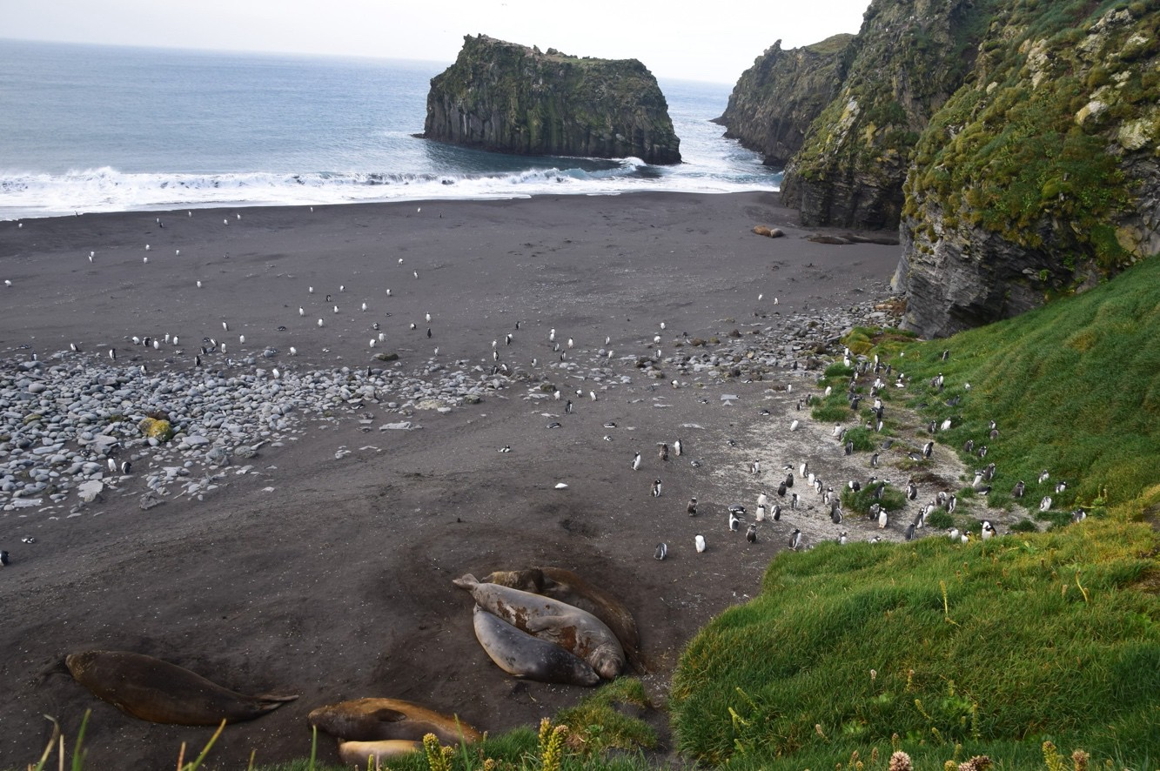

Image: Gentoo Penguins on Laurens Peninsula, Heard Island, 2016 © Fred Belton/AAD

# Pressures on the HIMI marine ecosystem

## Direct human activities

### Tourism

Occasional tourist vessels visit the HIMI Marine Reserve. Transiting the Marine Reserve does not require a permit unless entering Australia’s territorial waters within 12 nm of the islands, where all proposed activities require a permit to access the Territory of Heard Island and McDonald Islands (HIMI) under the *Environment Protection and Management Ordinance 1987*e (EPMO) made under the *Heard Island and McDonald Islands Act 1953.*f

Vessels must abide by approach guidelines for cetaceans prescribed under the EPBC Act 1999. Ballast water can be exchanged in the Reserve outside territorial waters, but any discharge of oil, oily waste or sludge is prohibited. Noting the low frequency of such visits and the strict regulation of activities, the risk of significant negative impacts to the conservation values described above from tourism is very low.

### Research

Scientific research in the HIMI Marine Reserve requires a permit under the EPBC Act 1999, and under the EPMO if it enters and is conducted in the territorial waters.

A dedicated Australian research voyage to study volcanic sources of iron in the ocean and atmosphere was conducted from the *RV Investigator* in 2016. The *RV Investigator* returned in 2020 to study the formation of Williams Ridge within and adjacent to the HIMI EEZ.

An annual random stratified trawl survey is conducted from aboard a commercial fishing vessel and includes a limited number of stations in the Marine Reserve. This is permitted on the basis that the removal of organisms is minor, decremented from catch limits and it provides important scientific data that informs the HIMI Marine Reserve Management Plan and supports assessments of the ecological sustainability of the HIMI fishery(Commonwealth of Australia, 2014; Ziegler & Welsford, 2019).

Data collected in this survey has been used to populate ecosystem(Subramaniam et al., 2020, 2022) and biogeographic models (Hill et al., 2017), update regular population assessments of target and common finfish bycatch species and set precautionary catch limits (Candy et al., 2011; Maschette &

e Environment Protection and Management Ordinance 1987 (HIMI) <https://www.legislation.gov.au/Details/F2014C01141> accessed 27 October 2023.

f *Heard Island and McDonald Islands Act 1953* https://[www.legislation.gov.au/Series/C1953A00007](http://www.legislation.gov.au/Series/C1953A00007) accessed 27 October 2023.

Welsford, 2019; Nowara et al., 2017; Péron et al., 2016; Yates et al., 2018; Ziegler & Welsford, 2019), and has been a key input into ecological risk assessments of the HIMI fishery (Sporcic et al., 2018).

Given the limited survey effort and the strict regulation of activities, the risk of significant negative impacts to the conservation values described above from scientific research is low.

### Fishing

The majority of direct human activities in the region relate to commercial fishing for Patagonian toothfish (*Dissostichus eleginoides*) and mackerel icefish (*Champsocephalus gunnari*). A history of the development of these fisheries is summarised in Constable & Welsford (2011) and Ziegler & Welsford (2019), and current status in Patterson & Curtotti (2023) and CCAMLR Secretariat (2021). Briefly, after unregulated fishing by eastern bloc countries in the 1970s, Australia declared a 200 nm EEZ around HIMI in 1979. Limited fishing occurred between 1979 and 1997, after which quantities of Patagonian toothfish and mackerel icefish that were considered sufficiently abundant to support exploratory commercial fishing (Williams & de la Mare, 1995). Licenses were subsequently issued to an Australian company to use bottom and midwater trawls to target these species. Illegal, unregulated, and unreported (IUU) longline fishing vessels targeted toothfish in the region during the late 1990s and early 2000s, but all such activities have ceased in the HIMI EEZ. Since 2007, longline fishing effort has increased to become the primary method targeting toothfish, while demersal and midwater trawl is more used to target icefish.

The HIMI fishery is regulated by the Australian Fisheries Management Authority, consistent with conservation measures adopted in CCAMLR. All vessels have scientific observers onboard. No commercial fishing is permitted in the HIMI Marine Reserve; however, research conducted using commercial fishing vessels is permitted under the Management Plan (Commonwealth of Australia, 2014). These fisheries are assessed as not overfished nor subject to overfishing (Patterson & Curtotti, 2023), and ecological risk assessments, last conducted using data to 2014/15 indicated that no vertebrate species or pelagic habitats required additional management action to mitigate risks from these fisheries at the time however any increase in bycatches of low productivity species such as skates would require re-evaluation (Bulman et al., 2017; Sporcic et al., 2018). Recent ecosystem modelling indicates that the current scale of fisheries removals is unlikely to result in significant changes to the food web in the region (Subramaniam et al., 2022). Research priorities for these fisheries include updated assessments for skate species and evaluating the robustness of the current toothfish harvest strategy to climate changeg.

Assessment of the impacts of bottom fishing methods on benthic habitats in the HIMI EEZ estimated that between 1997 and 2014, fishing had damaged or killed less than 2 percent of benthic organisms in areas of highest abundance less than 1200 metres deep, and that the Marine Reserve and a transition to longlining on deeper slopes was likely to overall reduce the impact of fishing on benthic organisms and habitats, noting that longlining activities focus on the deeper slopes between 800 and 2000 metres depth (Welsford et al., 2014; Ziegler & Welsford, 2019) where larger toothfish occur (Péron et al., 2016).

g Sixty-ninth meeting of the Sub-Antarctic Resource Group (afma.gov.au)

### Climate change

The extent of climate change impacts on the conservation values in the region is uncertain due to a lack of sustained observations. Data collected in the region from the late 19th and early 20th centuries indicates that sea surface temperature has warmed by around 1 degree Celsius, with warming undetected deeper than 750 metres. Recent observations indicate that marine heat waves (MHWs) have occurred in the region, raising temperatures over the entire plateau to depths of around 600 metres. These MHWs have been linked with short term changes in catch rates of toothfish, possibly due to changes in behaviour of mesopelagic prey species (Su et al., 2021).

Recent modelling indicates that MHWs and extreme weather events are likely to become more common across the region over the next 40 years. Average sea surface temperatures are forecast to increase 1–1.5 degrees Celsius by 2100. Wind speeds are also forecast to intensify, with more rapid changes in the second half of the century under scenarios where global carbon emissions are not rapidly reduced (Azarian et al., 2023).

Ecosystem modelling indicates that increases in temperature primarily impact marine biota through reduction in primary productivity. While increased wind speeds may compensate through increasing mixing of surface waters, most taxa — with the exception of whales — are predicted to decline in abundance (Fulton et al., 2021; Subramaniam et al., 2020). Spatially explicit habitat and food web models indicate that the current Marine Reserve will continue to provide protection to most taxa as climate change continues; however, it may increase the importance of the high productivity areas east of HIMI to seals and seabirds in the region as productivity declines in waters further north (Subramaniam et al., 2022).

### Marine pollution

The conservation values noted above are threatened by different types of marine pollution, including plastic debris, heavy metals such as mercury, and petrochemical spills. Beach surveys during the early 1987-1989s indicated that levels of plastic debris were relatively low at Heard Island compared to Macquarie Island and other sub-Antarctic islands (Slip & Burton, 1991). Slip & Burton (1999) noted that around 40 percent of plastic debris observed at Heard Island was fishing debris. As their surveys pre- date the start of the Australian fisheries in the region, their origins are likely to have been outside of the HIMI EEZ. Currently, vessels entering the HIMI EEZ are forbidden from disposing of any plastics overboard, and entanglement risks such as plastic bands used to secure boxes are required to be incinerated (Australian Fisheries Management Authority, 2021). A recent circumpolar survey of floating plastics found very low concentrations of macro and micro plastics south of the subtropical front (Suaria et al., 2020), however recent data from the HIMI EEZ is lacking.

The HIMI Marine Reserve does not sit across any transport routes, and no significant oil spills have been recorded in the region (Australian Maritime Safety Authority, 2020). Similarly, due to its remoteness from industrial sources and the barrier posed by the Subantarctic front, levels of other pollutants such as mercury in the region are relatively low, even in apex predators such as seabirds (Carravieri et al., 2016), pilot whales (Fontaine et al., 2015) and toothfish (Collins et al., 2010).

The longline fishery at HIMI loses sections of fishing gear, and industry is encouraged to recover it wherever possible. As longlines require bait to fish, and catch rates decline rapidly for gear set for longer than a few days, there is no indication that hooks continue to attract fish after gear is lost.

Given its design and management requirements to sink rapidly to avoid bird bycatch, longlines are likely to stay attached to the seafloor. Other impacts of lost gear are unknown.

### Invasive species and species range extensions

No records of invasive marine species observed in the HIMI EEZ were found. Recent risk assessments incorporating current and future climate scenarios indicated that the highest threat comes from the North Pacific seastar, *Asterias amurensis*. However, the likelihood of establishment of invasive marine species in the HIMI EEZ through hull fouling was estimated to be unlikely due to its remoteness from source populations, depth and low water temperatures compared to the thermal tolerance of many known invasive species (Holland, 2023).

The longest time series of biological data in the HIMI EEZ comes from the random stratified demersal trawl surveys initiated from the Aurora Australis in 1990 and continued annually by the Australian fishing industry since 1999 (Constable & Welsford, 2011; Ziegler & Welsford, 2019). These data show that the composition of fish assemblages on the plateau has been relatively stable throughout the time series. While new species records have occurred or cryptic species discovered ( e.g. Smith et al., 2011), there is no indication of fish species from outside the HIMI EEZ extending their range into the region or displacing common species over the last 3 decades (Duhamel & Hautecoeur, 2009; Hill et al., 2017; Maschette, Lamb, et al., 2023; Williams & de la Mare, 1995). Bycatch species composition in the longline fishery has also been consistent through time (Bulman et al., 2017; Welsford & Lamb, 2013); however, small numbers of *D. mawsoni* have become more common in catches, possibly linked to increased fishing effort on the deeper slopes to the south in recent years (Maschette, Wotherspoon, et al., 2023; Ziegler & Welsford, 2019), or recovery of the population on the nearby BANZARE Bank that was depleted (McKinlay et al., 2008) and subsequently closed to commercial fishing by CCAMLR in 2007.

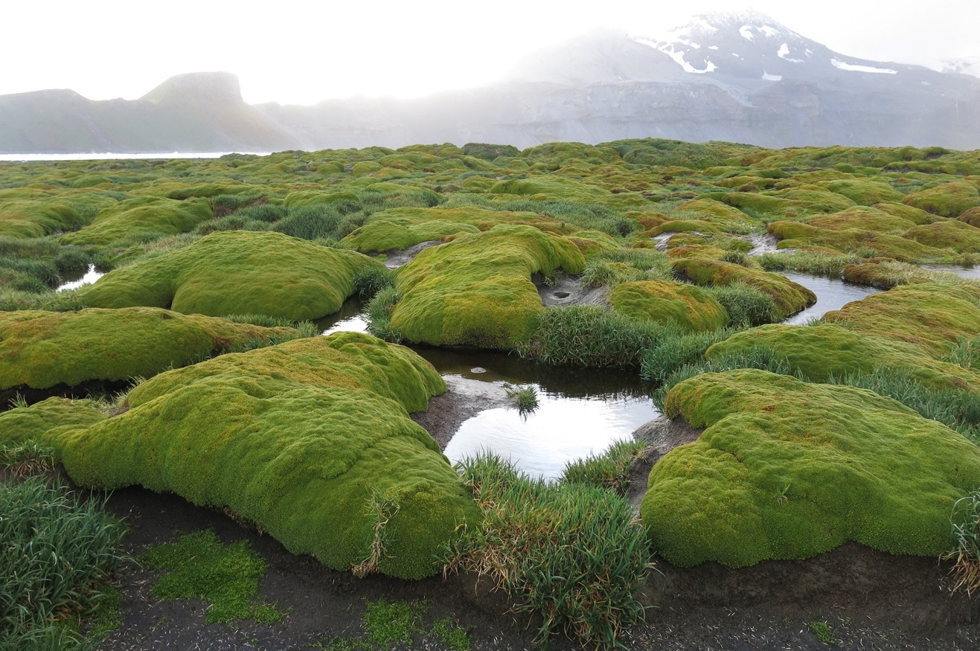

Image: Wharf Point, Heard Island, 2016 © Fred Belton/AAD

# Conclusion

This review supports the conclusions of previous analyses that the HIMI EEZ includes conservation values of national, regional and global significance (Commonwealth of Australia, 2014; Meyer et al., 2000). Recent studies confirm that significant conservation values exist in the diverse benthic assemblages on the shallow plateau and banks and upper slopes around Heard Island and McDonald Islands, as observed or predicted when the Marine Reserve was established in 2002 and expanded in 2014. Similarly, the deeper slopes and the high productivity pelagic environment over the deeper plateau and Shell Bank east of Heard Island support globally significant foraging areas for seabirds and marine mammals.

Additional data and modelling conducted since the 2014 management plan review identify that assemblages of high diversity and high biomass of habitat-forming benthic invertebrates are generally well represented in the Marine Reserve, having over 30 percent representation as they are concentrated on top of the banks. However, a distinct assemblage on the shallow plateau north of Heard Island is likely to support endemic fauna such as pycnogonids. Similarly, while there is some uncertainty as to their exact geomorphic classification, the relatively shallow (less than 1000 metres depth) tops of bathymetrically distinct banks and seamounts (sensu Brolsma, 2012) or ridge/plateau extension (sensu Post, 2016) located southeast of Shell Bank is likely to support important assemblages of benthic invertebrates that are vulnerable to damage from bottom contact sampling or harvesting methods. Finally, taxa such as basket stars that tend to be more common on the deeper plateau and upper slopes are currently not as well represented as other habitat forming taxa. Management for these areas warrants further evaluation to ensure they are being afforded adequate protection from disturbance of the seafloor, such as from demersal trawls or scientific sampling.

Statistical analysis indicates that seven distinct fish assemblages exist on the plateau and slopes of the HIMI EEZ. They are all represented in the Marine Reserve to varying degrees. The Region of Common Profile 1 assemblage – comprising diverse fish species associated with the deeper plateau and upper slope – is relatively poorly represented and contains relatively high abundances of skates that are vulnerable to overfishing. This area therefore warrants further consideration to ensure that the current management affords adequate protection to these values.

Recent syntheses of tagging and tracking data indicates that there are areas in the HIMI EEZ of global importance for vulnerable and endangered seabirds and marine mammals. The deep, high nutrient, low chlorophyll region to the west, south of the plateau is important for wandering and light mantled albatrosses, and the southeast is important for macaroni penguins, and likely to become more important under future climate change scenarios. Notably these analyses rely on limited data from animals resident in the HIMI EEZ and are over two decades old. These areas are currently relatively poorly represented in the HIMI Marine Reserve, and so evaluation is warranted to ensure that current management arrangements prevent processes that pose a high risk to vertebrate seabirds and marine mammals such as pelagic longlining, or processes that significantly impact the productivity of these areas such as geoengineering. Similarly, the pelagic region of high primary productivity between southern Gunnari Ridge and Shell Bank, and southeast of Shell Bank are globally important foraging areas for macaroni penguins and are relatively poorly represented in the Marine Reserve. As they are also predicted to increase in importance as climate change progresses, further consideration of appropriate management of this area is warranted.

# Appendix A: Vertebrate species recorded in the HIMI EEZ

**Table A 1 Provisional list of fish species reported from the Australian EEZ around Heard Island and the McDonald Islands, main habitat type and fishery where species have been recorded, derived from published lists by Williams and De la Mare (1995) and data collected from commercial and research fishing held at AAD Lamb et al. (2006). Habitats: C = coastal (less than 200 m, nearshore), S = shallow (200‐500 metres, banks and shallow plateau), D = deep (500 plus metres, deep plateau and slope), p = pelagic, d= demersal. Capture methods: LL = commercial longline, MT = commercial midwater trawl, DT= commercial demersal trawl, DP= commercial demersal traps, RMT= research midwater trawl, RDT= research demersal trawl.**

|  |  |  |  |  |  |
| --- | --- | --- | --- | --- | --- |
| **Class** | **Family** | **Species (taxonomic authority)** | **Common name** | **Habitats** | **Fishery** |
| ELASMOBRANCHII | Lamnidae | *Lamna nasus* (Bonnaterre 1788) | Porbeagle shark | S, p d | MT DT |
|  | Etmopteridae | *Etmopterus viator* (Straube 2011) | Blue‐eyed lanternshark | D, d | LL DT |
|  | Somniosidae | *Somniosus antarcticus* Whitley 1939 | Antarctic sleeper shark | D, d | LL DT DP |
|  | Rajidae | *Amblyraja* sp. | Skate | D,d | LL |
|  |  | *Bathyraja eatonii* (Günther, 1876) | Eaton’s skate | S D, d | LL DT |
|  |  | *Bathyraja irrasa* Hureau & Ozouf‐Castaz 1980 | Sandpaper skate | S D, d | LL DT |
|  |  | *Bathyraja murrayi* (Günther 1880) | Murray’s skate | C S, d | LL DT DP |
| ACTINOPTERYGII | Notacanthidae | *Notacanthus chemnitzii* Bloch 1788 | Cosmopolitan spineback | D, d | DT |
|  | Nemichthyidae | ?*Labichthys yanoi* (Mead & Rubinoff, 1966) | Yano’s snipe eel | D, d | DT |
|  | Microstomatidae | *Nansenia antarctica* Kawaguchi & Butler 1984 | Antarctic smallmouth | D, p | RMT |
|  | Bathylagidae | *Bathylagus antarcticus* Günther 1878 | Antarctic deepsea smelt | D, p | DT RMT |
|  | Gonostomatidae | *Cyclothone* sp. | Bristlemouth | D, p | RMT |
|  | Alepocephalidae | *Alepocephalus* sp. | Slickhead | D, d | DT RDT |
|  |  | *Rouleina* sp. | Slickhead | D, p | DT RDT |
|  | Stomiidae | *Astronesthes* ?*psychrolutes* (Gibbs & Weitzman 1965) | Temperate snaggletooth | D, d | DT |
|  |  | *Borostomias antarcticus* (Lönnberg 1905) | Antarctic dragonfish | D, p | DT RMT |
|  |  | *Idiacanthus atlanticus* Brauer 1906 | Black dragonfish | D, p | DT RMT |
|  |  | *Stomias boa* (Risso 1810) | Boa scaly dragonfish | D, p | DT RMT |
|  |  | *Stomias gracilis* Garman 1899 | Slender dragonfish | D, p | RMT |
|  |  | *Trigonolampa miriceps* Regan & Trewavas 1930 | Threelight dragonfish | D, p | RMT |
|  | Scopelarchidae | *Lagiacrusichthys macropinna* Bussing & Bussing 1966 | Longfin pearleye | D, p | DT |
|  | Notosudidae | *Scopelosaurus* sp. | Waryfish | D, d | DT |
|  | Paralepididae | *Magnisudis prionosa* (Rofen 1963) | Southern barracudina | D, d | DT |
|  |  | *Notolepis coatsorum* Dollo 1908 | Antarctic barracudina | D, p d | DT RMT |
|  | Anotopteridae | *Anotopterus vorax* (Regan 1913) | Southern Ocean daggertooth | D, d | DT DP |
|  | Alepisauridae | *Alepisaurus brevirostris* Lowe 1833 | Short‐snouted lancetfish | D, d | DT |
|  | Myctophidae | *Electrona antarctica* (Günther 1878) | Antarctic lanternfish | D, p | RMT |

**Table A1 Continued**

|  |  |  |  |  |  |
| --- | --- | --- | --- | --- | --- |
| Class | **Family** | **Species (taxonomic authority)** | **Common name** | **Habitats** | **Fishery** |
| ACTINOPTERYGII | Myctophidae | *Electrona carlsbergi* (Tåning 1932) | Carlsberg’s lanternfish | D, p | RMT |
|  |  | *Electrona subaspera* (Günther 1864) | Rough lanternfish | D, p | RMT |
|  |  | *Gymnoscopelus bolini* (Andriashev 1962) | Grand lanternfish | D, p | RMT |
|  |  | *Gymnoscopelus braueri* (Günther 1878) | Brauer’s lanternfish | D, p | RMT |
|  |  | *Gymnoscopelus fraseri* (Lönnberg 1905) | Fraser’s lanternfish | D, p | RMT |
|  |  | *Gymnoscopelus hintonoides* Hulley 1981 | False Midas lanternfish | D, p | RMT |
|  |  | *Gymnoscopelus nicholsi* (Gilbert 1911) | Nichols’ lanternfish | D, p | RMT |
|  |  | *Gymnoscopelus* sp. | Lanternfish | D, p | RMT |
|  |  | *Krefftichthys anderssoni* (Lönnberg 1905) | Rhombic lanternfish | D, p | RMT |
|  |  | *Lampanyctus achirus* (Andriashev 1962) | Cripplefin lanternfish | D, p | RMT |
|  |  | *Metelectrona ventralis* (Bekker 1963) | Flaccid lanternfish | D, p | RMT |
|  |  | *Protomyctophum andriashevi* (Bekker 1963) | Andriashev’s lanternfish | D, p | RMT |
|  |  | *Protomyctophum bolini* (Fraser‐Brunner 1949) | Bolin’s lanternfish | D, p | RMT |
|  |  | *Protomyctophum choriodon* (Hulley 1981) | Gaptooth lanternfish | D, p | RMT |
|  |  | *Protomyctophum gemmatum* (Hulley 1981) | Jewelled lanterfish | D, p | RMT |
|  |  | *Protomyctophum parallelum* (Lönnberg 1905) | Parallel lanternfish | D, p | RMT |
|  |  | *Protomyctophum tenisoni* (Norman 1930) | Tenison’s lanternfish | D, p | RMT |
|  |  | *Protomyctophum* sp. | Lanternfish | D, p | RMT |
|  | Lamprididae | *Lampris immaculatus* (Gilchrist 1904) | Southern opah | S D, p | MT DT |
|  | Muraenolepididae | *Muraenolepis marmorata* Günther 1880 | Marbled moray cod | S D, d | DT |
|  |  | *Muraenolepis microps* Lönnberg 1905 | Smalleye moray cod | S D, d | DT |
|  |  | *Muraenolepis orangiensis* Vaillant 1888 | Patagonian moray cod | S, d | DT |
|  | Macrouridae | *Coryphaenoides armatus* (Hector 1875) | Abyssal grenadier | D, d | DT |
|  |  | *Cynomacrurus piriei* Dollo 1909 | Dogtooth grenadier | D, d | DT |
|  |  | *Macrourus caml* McMillan *et al.* 2012 | Caml grenadier | D, d | LL DT |
|  |  | *Macrourus carinatus* (Günther 1878) | Ridgescale grenadier | D, d | LL DT |
|  |  | *Macrourus holotrachys* Günther 1878 | Bigeye grenadier | D, d | LL DT |
|  |  | *Macrourus whitsoni* (Regan 1913) | Whitson's grenadier | D, d | LL DT |
|  | Moridae | *Antimora rostrata* (Günther 1878) | Violet cod | D, d | LL DT |
|  |  | *Guttigadus kongi* (Markle & Meléndez 1988) | Austral cod | S, d | DT |
|  |  | *Halargyreus johnsonii* Günther 1862 | Slender cod | D, d | DT |
|  |  | *Lepidion microcephalus* Cowper 1956 | Smallheaded cod | D, d | DT |
|  |  | *Lepidion* sp. | Patagonian cod | D, d | DT |
|  | Melanonidae | *Melanonus gracilis* Günther 1878 | Pelagic cod | D, p | DT |
|  | Carapidae | *Echiodon cryomargarites* Markle, Williams & Olney 1983 | Pearlfish | D, d | DT |

**Table A1 Continued**

|  |  |  |  |  |  |
| --- | --- | --- | --- | --- | --- |
| **Class** | **Family** | **Species (taxonomic authority)** | **Common name** | **Habitats** | **Fishery** |
| ACTINOPTERYGII | Himantolophidae | *Himantolophus* sp. | Footballfish | D, d | DT |
|  | Ceratiidae | *Ceratias tentaculatus* (Norman 1930) | Southern seadevil | D, d | DT |
|  | Melamphaidae | *Poromitra atlantica* (Norman 1929) | Crested bigscale | D, p | DT |
|  | Cetomimidae | *Gyrinomimus grahami* Richardson & Garrick 1964 | Flabby whalefish | D, p | RMT |
|  | Barbourisiidae | *Barbourisia rufa* Parr 1945 | Red velvet whalefish | D, p | RMT |
|  | Oreosomatidae | *Pseudocyttus maculatus* Gilchrist 1906 | Smooth Oreo | D, d | DT |
|  | Congiopodidae | *Zanclorhynchus spinifer* Günther 1880 | Spiny horsefish | C S, d | DT |
|  | Liparidae | *Paraliparis operculosus* Andriashev 1979 | Longeared snailfish | D, d | DT |
|  |  | *Paraliparis* sp. | Snailfish | D, d | DT |
|  | Zoarcidae | *Lycodapus antarcticus* Tomo 1981 | Antarctic eelpout | D, d | DT |
|  |  | *Melanostigma gelatinosum* Günther 1881 | Limp eelpout | D, d | DT |
|  | Nototheniidae | *Dissostichus eleginoides* Smitt 1898 | Patagonian toothfish | S D, d | LL DT DP RDT |
|  |  | *Dissostichus mawsoni* Norman 1937 | Antarctic toothfish | S D, d | LL DT |
|  |  | *Gobionotothen acuta* (Günther 1880) | Triangular rockcod | C S, d | DT |
|  |  | *Lepidonotothen squamifrons* (Günther 1880) | Grey rockcod | C S, d | DT |
|  |  | *Lindbergichthys mizops* (Günther 1880) | Toad rockcod | S, d | DT |
|  |  | *Notothenia cyanobrancha* Richardson 1844 | Bluegill rockcod | C, d | DT RDT |
|  |  | *Notothenia coriiceps* Richardson 1844 | Black rockcod | C, d | DT RDT |
|  |  | *Notothenia rossii* Richardson 1844 | Marbled rockcod | C S, d | DT RDT |
|  |  | *Paranothothenia magellanica* (Forster 1801) | Orange throated rockcod | C, d | DT RDT |
|  | Harpagiferidae | *Harpagifer spinosus* Hureau, Louis, Tomo & Ozouf 1980 | Spiny plunderfish | C, d | DT |
|  | Bathydraconidae | *Bathydraco antarcticus* Günther 1878  *Bathydraco* sp. | Antarctic dragonfish  Dragonfish | D, d  D, d | DT  RMT RDT |
|  | Channichthyidae | *Champsocephalus gunnari* Lönnberg 1905 | Mackerel icefish | S, p d | MT DT |
|  |  | *Channichthys rhinoceratus* Richardson 1844 | Unicorn icefish | C S, p d | MT DT |
|  |  | *Pagetopsis macropterus* (Boulenger 1907) | Crocodile icefish | C S, d | DT |
|  | Gempylidae | *Paradiplospinus gracilis* (Brauer 1906) | Slender snake mackerel | S D, p | DT RMT |
|  | Centrolophidae | *Icichthys australis* Haedrich 1966 | Southern driftfish | D, p | DT RMT |
|  | Achiropsettidae | *Achiropsetta* sp*.* | Grey flounder | S, d | DT |
|  |  | *Mancopsetta maculata* (Günther 1880) | Spotted armless flounder | S, d | DT |
|  |  | *Neoachiropsetta milfordi* Penrith 1965 | Largemouth armless flounder | S D, d | DT |

**Table A 2 Provisional list of seabirds recorded in the HIMI EEZ derived from published lists in Commonwealth of Australia (2014) and data held at AAD, including records of birds observed at sea from commercial fishing vessels (Lamb et al., 2006). *Environment Protection and Biodiversity Conservation Act 1999* (EPBC) Status from Department of the Environment (2023a). U= no listing information, E = endangered, V**

**= Vulnerable, M = Migratory, Mar= Marine. International Union for Conservation of Nature and Natural Resources categories from IUCN (2023).**

|  |  |  |  |  |
| --- | --- | --- | --- | --- |
| **Family** | **Species (taxonomic authority)** | **Common name** | **EPBC Status** | **IUCN Category** |
| Diomedeidae | *Diomedea amsterdamensis* (Roux *et al*. 1983) | Amsterdam albatross | V, M, Mar | Endangered |
|  | *Diomedea epomophora* Lesson 1825 | Southern royal albatross | V, M, Mar | Vulnerable |
|  | *Diomedea exulans* Linnaeus 1758 | Wandering albatrossb | V, M, Mar | Vulnerable |
|  | *Thalassarche chrysostoma* (Forster 1785) | Grey‐headed albatrossc | E, M, Mar | Vulnerable |
|  | *Phoebetria fusca* (Hilsenberg 1822) | Sooty albatrossc | V, M, Mar | Endangered |
|  | *Phoebetria palpebrata* (Forster 1785) | Light‐mantled albatrossa | M, Mar | Near threatened |
|  | *Thalassarche bulleri* (Rothschild 1893) | Buller’s albatross | V, M, Mar | Near Threatened |
|  | *Thalassarche carteri* (Rothschild 1903)  *Thalassarche chlororhynchos* (Gmelin 1789) | Indian yellow‐nosed albatross Atlantic yellow‐nosed albatross | V, M, Mar  M, Mar | Endangered Endangered |
|  | *Thalassarche melanophris* (Temminck 1828) | Black‐browed albatrossa,c | V, M, Mar | Least concern |
| Hydrobatidae | *Fregetta grallaria* (Vieillot 1817) | White‐bellied storm petrel | V, Mar | Least concern |
|  | *Fregetta tropica* (Gould 1844) | Black‐bellied storm petrel | Mar | Least concern |
|  | *Garrodia nereis* (Gould 1841) | Grey‐backed storm petrel | Mar | Least concern |
| Laridae | *Larus dominicanus* (Lichtenstein 1823) | Kelp gulla | Mar | Least concern |
|  | *Sterna paradisaea* (Pontoppidan 1763) | Arctic tern | Mar | Least concern |
|  | *Sterna vittata* (Gmelin 1789) | Antarctic terna | V, Mar | Least concern |
| Phalacrocoracidae | *Leucocarbo atriceps nivalis* (Falla 1937) | Heard Island imperial shag* | V, Mar | Least concern |
| Procellariidae | *Daption capense* (Linnaeus 1758) | Cape petrela,c | Mar | Least concern |
|  | *Fulmarus glacialoides* (Smith 1840) | Southern fulmar | Mar | Least concern |
|  | *Halobaena caerulea* (Gmelin 1789) | Blue petrel | V, Mar | Least concern |
|  | *Aphodroma brevirostris* (Lesson 1831) | Kerguelen petrel | Mar | Least concern |
|  | *Macronectes giganteus* (Gmelin 1789) | Southern giant petrela,c | E, M, Mar | Vulnerable |
|  | *Macronectes halli (*Mathews 1912) | Northern giant petrelc | V, M, Mar | Near threatened |
|  | *Oceanites oceanicus* (Kuhl 1820) | Wilson’s storm petrela | M, Mar | Least concern |
|  | *Pachyptila belcheri* (Mathews 1912) | Slender‐billed prion | Mar | Least concern |

a Breeds at HIMI; b Sporadically breeds at HIMI; c Species recorded in fishery bycatch events; d Rare vagrant; * Endemic to inshore waters of HIMI.

**Table A2 continued**

|  |  |  |  |  |
| --- | --- | --- | --- | --- |
| **Family** | **Species (taxonomic authority)** | **Common name** | **EPBC Status** | **IUCN Category** |
| Procellaridae (cont.) | *Pachyptila desolata* (Gmelin 1789) | Fulmar priona | Mar | Least concern |
|  | *Pachyptila salvini* (Mathews 1912)  *Pachyptila turtur* (Kuhl 1820) | Salvin’s prion  Fairy priona | Mar  Mar | Least concern  Least concern |
|  | *Pachyptila vittata* (Forster 1777) | Broad‐billed prion | Mar | Least concern |
|  | *Pagodroma nivea* (Forster 1777) | Snow petrel‡ | Mar | Least concern |
|  | *Pterodroma baraui* (Jouanin 1964) | Barau’s petrel | Mar | Endangered |
|  | *Pterodroma inexpectata* (Forster 1844) | Mottled petrel | Mar | Near threatened |
|  | *Pterodroma lessonii* (Garnot 1826)  *Pterodroma macroptera* (Smith 1840) | White‐headed petrel  Great‐winged petrelc | Mar  Mar | Least concern  Least concern |
|  | *Pterodroma mollis* (Gould 1844) | Soft‐plumaged petrel | V, Mar | Least concern |
|  | *Procellaria aequinoctialis* (Linnaeus 1758)  *Procellaria cinerea* (Gmelin 1789)  *Procellaria conspicillata (*Gould 1844) | White‐chinned petrelc Grey petrelb,c  Spectacled petreld | M, Mar M, Mar  M | Vulnerable  Near threatened Vulnerable |
|  | *Puffinus griseus (Gmelin 1789)* | Sooty shearwater | M, Mar | Near threatened |
| Pelecanoididae | *Puffinus tenuirostris* (Temminck 1835)  *Thalassoica antarctica* (*Gmelin* 1789) *Pelecanoides georgicus* Murphy & Harper 1916 *Pelecanoides urinatrix* (Gmelin 1789) | Short‐tailed shearwater  Antarctic petrelc  South Georgian diving petrela Common diving petrela | M, Mar  Mar Mar Mar | Least concern  Least concern Least concern Least concern |
| Spheniscidae | *Aptenodytes forsteri* Gray 1844  *Aptenodytes patagonicus* Miller 1778 | Emperor penguin^  King penguina | U  Mar | Least concern  Least concern |
|  | *Eudyptes chrysocome* (Forster 1781)  *Eudyptes chrysolophus* (Brandt 1837) | Rockhopper penguina  Macaroni penguina | Mar  Mar | Vulnerable  Vulnerable |
|  | *Pygoscelis adeliae* (Hombron & Jacquinot 1841) | Adelie penguin | Mar | Least concern |
| Stercorariidae | *Pygoscelis antarcticus* (Forster 1781)  *Pygoscelis papua* (Forster 1781)  *Stercorarius antarcticus* (Lesson, 1831) | Chinstrap penguin  Gentoo penguina Subantarctic skuaa | Mar  Mar Mar | Least concern  Least Concern Least concern |
|  | *Stercorarius maccormicki (*Saunders 1893) | South polar skua | M, Mar | Least concern |

a Breeds at HIMI; b Sporadically breeds at HIMI; c Species recorded in fishery bycatch events; *Endemic to HIMI; ‡ Not sighted at HIMI since 1948; ^ Not sighted at HIMI since 1954.

**Table A 3 Marine mammal species in the HIMI EEZ derived from published lists in Commonwealth of Australia (2014) and data held at AAD, including records of mammals observed at sea from commercial fishing vessels (Lamb et al., 2006). *Environment Protection and Biodiversity Conservation Act 1999* (EPBC) Status from Department of the Environment (2023a). E = endangered, V = Vulnerable, M = Migratory, Mar= Marine, C=Cetacean. International Union for Conservation of Nature and Natural Resources categories from IUCN (2023).**

|  |  |  |  |  |
| --- | --- | --- | --- | --- |
| **Family** | **Species** | **Common name** | **EPBC Status** | **IUCN Category** |
| Otariidae | *Arctocephalus gazella (Peters 1875) Arctocephalus tropicalis* (Gray 1872) | Antarctic fur seala*\** Subantarctic fur sealb | Mar E, Mar | Least concern Least concern |
| Phocidae | *Hydrurga leptonyx* (Blainville 1820) | Leopard seal* | Mar | Least concern |
|  | *Leptonychotes weddellii* (Lesson 1826) | Weddell seal† | Mar | Least concern |
|  | *Lobodon carcinophagus* (Hombron & Jacquinot 1842) | Crabeater seal† | Mar | Least concern |
|  | *Mirounga leonina* (Linneaus 1758) | Southern elephant seala* | V, Mar | Least concern |
|  | *Ommatophoca rossii* (Gray 1844) | Ross seal† | Mar | Least concern |
| Balaenidae | *Eubalaena australis* (Desmoulins 1822) | Southern right whale | E, M, C | Least concern |
| Balaenopteridae | *Balaenoptera acutorostrata* (Lacepède 1804) | Minke whalec | C | Least concern |
|  | *Balaenoptera bonaerensis* (Burmeister 1867) | Antarctic minke whale | M, C | Near threatened |
|  | *Balaenoptera borealis* (Lesson 1828) | Sei whale | V, M, C | Endangered |
|  | *Balaenoptera musculus* (Linnaeus 1758) | Blue whale | E, M, C | Endangered |
|  | *Balaenoptera physalus* (Linnaeus 1758) | Fin whale | V, M, C | Vulnerable |
|  | *Megaptera novaeangliae* (Borowski, 1781) | Humpback whale | M, C | Least concern |
| Neobalaenidae | *Caperea marginata* (Gray 1846) | Pygmy right whale | M, C | Least concern |
| Ziphiidae | *Berardius arnuxii* Duvernoy 1851 | Arnoux’s beaked whale | C | Least concern |
|  | *Mesoplodon layardii* (Gray 1865) | Strap‐toothed beaked whalec | C | Least concern |
|  | *Hyperoodon planifrons* Flower 1882 | Southern bottlenose whalec | C | Least concern |
| Delphinidae | *Globicephala melas* (Traill 1809)  *Sagmatias australis (Peale, 1849)* | Long‐finned pilot whalec*  Hourglass dolphinc | C  Cd | Least concern  Least concernd |
|  | *Lagenorhynchus obscurus* (Gray 1828) | Dusky dolphin | M, C | Least concern |
| Phocoenidae | *Orcinus orca* (Linnaeus 1758)  *Phocoena dioptrica (*Lahille 1912) | Killer whale*  Spectacled porpoisec | M, C  M, C | Data deficient  Least concern |
| Physeteridae | *Physeter macrocephalus* (Linnaeus 1758) | Sperm whale* | M, C | Vulnerable |

a Breeds at HIMI; b Sporadically breeds at HIMI; c Species identified from skeletal remains collected from the shore on Heard Island; d as *Lagenorhynchus cruciger;* * Species recorded in vicinity of commercial fishing operations; † No recorded sightings at HIMI since 1950s

# References

Alcock, M. B., Taffs, N. J., & Zhong, Q. (2020). *Seas and Submerged Lands Act 1973 - Australian Maritime Boundaries 2020 - Geodatabase.* Geoscience Australia. <https://pid.geoscience.gov.au/dataset/ga/144571>

Arce, F., Hindell, M. A., McMahon, C. R., Wotherspoon, S. J., Guinet, C., Harcourt, R. G., & Bestley, S. (2022). Elephant seal foraging success is enhanced in Antarctic coastal polynyas. *Proceedings of the Royal Society B: Biological Sciences*, *289* (1967). <https://doi.org/10.1098/rspb.2021.2452>

Australian Fisheries Management Authority. (2021). *Management Arrangements for the Heard Island & McDonald Islands Fishery 2021-2022*. AFMA

Australian Fisheries Management Authority. (2023). *Threatened and Endangered Species Reporting* . <https://www.afma.gov.au/protected-species/threatened-and-endangered-species-reporting>

Australian Maritime Safety Authority. (2020). *Major Historical Incidents*. <https://www.amsa.gov.au/marine-environment/incidents-and-exercises/major-historical>- incidents

Azarian, C., Bopp, L., Pietri, A., Sallée, J. B., & d’Ovidio, F. (2023). Current and projected patterns of warming and marine heatwaves in the Southern Indian Ocean. *Progress in Oceanography*, *215*(103036), 103036. <https://doi.org/10.1016/j.pocean.2023.103036>

Beaman, R. J. (2023). *Kerguelen Plateau 100m bathymetric grid compilation (20220004C)*. Geoscience Australia. <https://dx.doi.org/10.26186/147703>

Beaman, R. J., & O’Brien, P. E. (2011). *Kerguelen Plateau Bathymetric Grid. Geoscience Australia Record 2011/22*. Geoscience Australia. <https://pid.geoscience.gov.au/dataset/ga/71670>

Branch, T., Stafford, K., Palacios, D., Allison, C., Bannister, J., Burton, C., Cabrera, E., Carlson, C., Galletti, B., Gill, P., Hucke-Gaete, R., Jenner, K., Jenner, M., Matsuoka, K., Mikhalev, Y., Miyashita, T., Morrice, M., Nishiwaki, S., Sturrock, V., & Warneke, R. (2007). Past and present distribution, densities and movements of blue whales *Balaenoptera musculus* in the Southern Hemisphere and northern Indian Ocean. *Mammal Review*, *37*, 116–175. <https://doi.org/10.1111/j.1365-2907.2007.00106.x>

Brolsma, H. (2012). *Kerguelen-Heard Island region - Mapping Under Sea Geomorphology, Ver. 1* .

Australian Antarctic Datacentre. https://doi.org/doi:10.26179/5b9b5078b6610

Brooks, C. M., Epstein, G., & Ban, N. C. (2019). Managing marine protected areas in remote areas: The case of the subantarctic Heard and McDonald Islands. *Frontiers in*

*Marine Science*, *6*. <https://doi.org/10.3389/fmars.2019.00631>

Bulman, C., Sporcic, M., Pethybridge, H., & Hobday, A. J. (2017). *Ecological Risk Assessment for the Effects of Fishing. Final Report for the Heard Island and McDonald Islands Fishery: Demersal longline sub-fishery 2010/11 to 2014/15*. CSIRO AFMA.

Candy, S. G., Welsford, D. C., Lamb, T., Verdouw, J. J., & Hutchins, J. J. (2011). Estimation of natural mortality for the Patagonian toothfish at Heard and McDonald Islands using catch-at-age and aged mark-recapture data from the main trawl ground. *CCAMLR Science*, *18,* 29-45. <https://www.ccamlr.org/en/system/files/science_journal_papers/02candy-et-al.pdf>

Carravieri, A., Cherel, Y., Jaeger, A., Churlaud, C., & Bustamante, P. (2016). Penguins as bioindicators of mercury contamination in the southern Indian Ocean: geographical and temporal trends.

*Environmental Pollution*, *213*, 195–205. <https://doi.org/10.1016/j.envpol.2016.02.010>

CCAMLR Secretariat. (2021). *Stock Assessment Report 2021:* Dissostichus eleginoides *at Heard Island (Division 58.5.2)*. <https://fishdocs.ccamlr.org/SAreport_HIMI_TOP_2021.pdf>

Cherel, Y., & Duhamel, G. (2003). Diet of the squid *Moroteuthis ingens* (Teuthoidea: Onychoteuthidae) in the upper slope waters of the Kerguelen Islands. *Marine Ecology Progress Series*, *250*, 197–203. <https://doi.org/10.3354/meps250197>

Cherel, Y., & Duhamel, G. (2004). Antarctic jaws: cephalopod prey of sharks in Kerguelen waters.

*Deep Sea Research Part I: Oceanographic Research Papers*, *51*(1), 17–31. <https://doi.org/10.1016/j.dsr.2003.09.009>

Cherel, Y., Duhamel, G., & Gasco, N. (2004). Cephalopod fauna of subantarctic islands: new information from predators. *Marine Ecology Progress Series*, *266*, 143–156. <https://doi.org/10.3354/meps266143>

Cherel, Y., Trouvé, C., & Bustamante, P. (2023). Cephalopod prey of light-mantled sooty albatross *Phoebetria palpebrata*, resource partitioning amongst Kerguelen albatrosses, and teuthofauna of the southern Indian Ocean. *Deep Sea Research Part I: Oceanographic Research Papers*, *198*, 104082. <https://doi.org/10.1016/j.dsr.2023.104082>

Coffin, M., Edwards, S., Kuna, N., & Navidad, C. (2020). *IN2020_V01 Williams Ridge Bathymetry 100m resolution AusSeabed products*. CSIRO. <https://doi.org/10.25919/5f7e3bcfe68e8>

Collins, M. A., Brickle, P., Brown, J., & Belchier, M. (2010). The Patagonian Toothfish. In *Advances in Marine Biology* (pp. 227–300). Elsevier. <https://doi.org/10.1016/b978-0-12-381015-1.00004-6>

Commonwealth of Australia. (2014). *Heard Island and McDonald Islands Marine Reserve Management Plan 2014-2024*. Department of the Environment, Canberra.

Commonwealth of Australia. (2023). *Australian Marine Parks - outer boundaries*. <https://gis.environment.gov.au/gispub/rest/services/marine/ncva/MapServer/3>

Constable, A. J., Melbourne-Thomas, J., Corney, S. P., Arrigo, K. R., Barbraud, C., Barnes, D. K. A., Bindoff, N. L., Boyd, P. W., Brandt, A., Costa, D. P., Davidson, A. T., Ducklow, H. W., Emmerson, L., Fukuchi, M., Gutt, J., Hindell, M. A., Hofmann, E. E., Hosie, G. W., Iida, T., … Ziegler, P. (2014).

Climate change and Southern Ocean ecosystems I: How changes in physical habitats directly affect marine biota. *Global Change Biology*, *20* (10). <https://doi.org/10.1111/gcb.12623>

Constable, A. J., & Welsford, D. (2011). Developing a precautionary ecosystem approach to managing fisheries and other marine activities at Heard Island and McDonald Islands in the Indian Sector

of the Southern Ocean. In G. Duhamel & D. Welsford (Eds.), *The Kerguelen Plateau: marine ecosystem and fisheries* (pp. 233–255). Société Française d’Ichtyologie. <https://doi.org/10.26028/cybium/2011-35SP-026>

Corliss, B. A., Delalio, L. J., Stevenson Keller, T. C., Keller, A. S., Keller, D. A., Corliss, B. H., Beers, J. M., Peirce, S. M., & Isakson, B. E. (2019). Vascular Expression of Hemoglobin Alpha in Antarctic Icefish Supports Iron Limitation as Novel Evolutionary Driver. *Frontiers in Physiology*, *10*. <https://doi.org/10.3389/fphys.2019.01389>

Cotté, C., Ariza, A., Berne, A., Habasque, J., Lebourges-Dhaussy, A., Roudaut, G., Espinasse, B., Hunt,

B. P. V, Pakhomov, E. A., Henschke, N., Péron, C., Conchon, A., Koedooder, C., Izard, L., & Cherel,

Y. (2022). Macrozooplankton and micronekton diversity and associated carbon vertical patterns and fluxes under distinct productive conditions around the Kerguelen Islands. *Journal of Marine Systems*, *226* (103650), 103650. <https://doi.org/10.1016/j.jmarsys.2021.103650>

Cristofari, R., Liu, X., Bonadonna, F., Cherel, Y., Pistorius, P., Le Maho, Y., Raybaud, V., Stenseth, N. C.,

Le Bohec, C., & Trucchi, E. (2018). Climate-driven range shifts of the king penguin in a fragmented ecosystem. *Nature Climate Change*, *8* (3), 245–251. <https://doi.org/10.1038/s41558-018-0084-2>

De Broyer, C., Koubbi, P., Griffiths, H., Raymond, B., d’, U., Van de Putte, A., Danis, B., David, B., Grant, S., Gutt, J., Held, C., Hosie, G., Huettmann, F., Post, A., & Ropert-Coudert, Y. (2014). *Biogeographic Atlas of the Southern Ocean*. Scientific Committee on Antarctic Research, Cambridge

Deagle, B. E., Gales, N. J., Evans, K., Jarman, S. N., Robinson, S., Trebilco, R., & Hindell, M. A. (2007). Studying seabird diet through genetic analysis of faeces: a case study on Macaroni penguins [(*Eudyptes chrysolophus*). *PLoS ONE*, *2* (9), e831. https://doi.org/10.1371/](https://doi.org/10.1371/journal.pone.0000831)

[journal.pone.0000831](https://doi.org/10.1371/journal.pone.0000831)

Department of the Environment. (2023a). *Species Profile and Threats Database*. [https://www.environment.gov.au/sprat.](https://www.environment.gov.au/sprat)

Department of the Environment. (2023b). Arctocephalus gazella*: Species Profile and Threats Database*. [https://www.environment.gov.au/sprat.](https://www.environment.gov.au/sprat)

Department of the Environment. (2023c). Eubalaena australis*: Species Profile and Threats Database*. [https://www.environment.gov.au/sprat.](https://www.environment.gov.au/sprat)

Department of the Environment. (2023d). Lamna nasus*: Species Profile and Threats Database*. [https://www.environment.gov.au/sprat.](https://www.environment.gov.au/sprat)

Department of the Environment. (2023e). Mirounga leonina*: Species Profile and Threats Database*. [https://www.environment.gov.au/sprat.](https://www.environment.gov.au/sprat)

Duhamel, G., Gasco, N., & Davaine, P. (2005). Poissons des îles Kerguelen et Crozet : Guide régional de l’océan Austral. *Collection Patrimoines Naturels*, *63*. Muséum national d'Histoire naturelle, Paris.

Duhamel, G., & Hautecoeur, M. (2009). Biomass, abundance and distribution of fish in the Kerguelen Islands EEZ (CCAMLR Statistical Division 58.5.1). *CCAMLR Science*, *16*, 1–32. <https://www.ccamlr.org/fr/system/files/science_journal_papers/01duhamel-hautecoeur.pdf>

Duhamel, G., & King, N. (2007). Deep-sea snailfish (Scorpaeniformes: Liparidae) of genera *Careproctus* and *Paraliparis* from the Crozet Basin (Southern Ocean). *Cybium*, *31*, 376–384. <https://doi.org/10.26028/cybium/2007-313-007>

Dulvy, N. K. , Bineesh, K. K., Cheok, J., Dharmadi, Finucci, B., Pacoureau, N., & Sherman, C. S. (2020).

*Bathyraja irrasa*. *The IUCN Red List of Threatened Species 2020: E.T161659A124523337.*

https://doi.org/https://doi.org/10.2305/IUCN.UK.2020-3.RLTS.T161659A124523337.en

Duncan, R. A., Quilty, P. G., Barling, J., & Fox, J. M. (2016). Geological development of Heard Island, Central Kerguelen Plateau. *Australian Journal of Earth Sciences*, *63*(1), 81–89. <https://doi.org/10.1080/08120099.2016.1139000>

Feral, J. P., & Poulin, E. (2011). Kerguelen Islands: a living laboratory to understand the benthic biodiversity of the Antarctic. In G. Duhamel & D. Welsford (Eds.), *The Kerguelen Plateau, Marine Ecosystem and Fisheries* (pp. 151–156). Société Française d’Ichtyologie. <https://doi.org/10.26028/cybium/2011-35SP-0>

Fontaine, M., Carravieri, A., Simon-Bouhet, B., Bustamante, P., Gasco, N., Bailleul, F., Guinet, C., & Cherel, Y. (2015). Ecological tracers and at-sea observations document the foraging ecology of southern long-finned pilot whales (*Globicephala melas edwardii*) in Kerguelen waters. *Marine Biology*, *162*(1), 207–219. <https://doi.org/10.1007/s00227-014-2587-3>

Fulton, E. A. , G. , H. A. J., van Putten, E. I., Dutra, L. X. C., Melbourne-Thomas, J., Ogier, E., Thomas, L., Rayns, N., Murphy, R., Butler, I., Ghebrezgabhier, D., & Hobday, A. J. (2021). *Guidance on Adaptation of Commonwealth Fisheries management to climate change.* CSIRO report for FRDC. <https://www.frdc.com.au/sites/default/files/products/2016-059-DLD.pdf>

Gasco, N., Tixier, P., Karine, D., Guinet, C., & Duhamel, G. (2019). Scientific observation program around Kerguelen Island, a ship-of-opportunity for bird and mammal data collection. In D. Welsford, J. Dell, & G. Duhamel (Eds.), *The Kerguelen Plateau: marine ecosystem and fisheries. Proceedings of the Second Symposium.* (pp. 365–379). Australian Antarctic Division.

GEBCO Compilation Group. (2019). *GEBCO 2019 Grid*. https://doi.org/doi:10.5285/836f016a-33be- 6ddc-e053-6c86abc0788e.

GEBCO Compilation Group. (2023). *GEBCO 2023 Grid*. https://doi.org/doi:10.5285/f98b053b-0cbc- 6c23-e053-6c86abc0af7b

Goldsworthy, S., Page, B., Welling, A., Chambellant, M., & Bradshaw, C. (2010). Selection of diving strategy by Antarctic fur seals depends on where and when foraging takes place. *Marine Ecology Progress Series*, *409*, 255–266. <https://doi.org/10.3354/meps08611>

Gon, O., & Heemstra, P. C. (1990). *Fishes of the Southern Ocean*. J.L.B. Smith Institute of Ichthyology. <https://doi.org/10.5962/bhl.title.141868>

Griffiths, H. J., Barnes, D. K. A., & Linse, K. (2009). Towards a generalized biogeography of the Southern Ocean benthos. *Journal of Biogeography*, *36*(1), 162–177. <https://doi.org/10.1111/j.1365-2699.2008.01979.x>

Hibberd, T. (2014). Macro-epibenthic faunal diversity and assemblages in the Heard Island and McDonald Islands region. In D. Welsford, G. Ewing, A. J. Constable, T. Hibberd, & R. Kilpatrick (Eds.), *Demersal fishing interactions with marine benthos in the Australian EEZ of the Southern Ocean: An assessment of the vulnerability of benthic habitats to impact by demersal gears*. Final Report FRDC Project 2006/042. <https://www.frdc.com.au/project/2006-042>

Hibberd, T., Candy, S., & Ewing, G. (2014). Prediction of vulnerable marine benthos across the Heard Island and McDonald Islands region. In *Demersal fishing interactions with marine benthos in the Australian EEZ of the Southern Ocean: An assessment of the vulnerability of benthic habitats to impact by demersal gears*. Final Report FRDC Project 2006/042. <https://www.frdc.com.au/project/2006-042>

Hill, N. A., Foster, S. D., Duhamel, G., Welsford, D., Koubbi, P., & Johnson, C. R. (2017). Model-based mapping of assemblages for ecology and conservation management: A case study of demersal fish on the Kerguelen Plateau. *Diversity and Distributions*, *23*(10). <https://doi.org/10.1111/ddi.12613>

Hindell, M. A., Lea, M., Bost, C., Charrassin, J.-B., Gales, N., Goldsworthy, S., Page, B., Roberstson, G., Wienecke, B., O’Toole, M., & Guinet, C. (2011). Foraging habitats of top predators, and Areas of Ecological Significance, on the Kerguelen Plateau. In G. Duhamel & D. Welsford (Eds.), *The Kerguelen Plateau: marine ecosystem and fisheries* (pp. 203–215). Société Française d’Ichtyologie. <https://doi.org/doi>: 10.26028/cybium/2011-35SP-024

Hindell, M. A., McMahon, C. R., Bester, M. N., Boehme, L., Costa, D., Fedak, M. A., Guinet, C., Herraiz- Borreguero, L., Harcourt, R. G., Huckstadt, L., Kovacs, K. M., Lydersen, C., McIntyre, T., Muelbert, M., Patterson, T., Roquet, F., Williams, G., & Charrassin, J. (2016). Circumpolar habitat use in the southern elephant seal: implications for foraging success and population trajectories. *Ecosphere*, *7*(5). <https://doi.org/10.1002/ecs2.1213>

Hindell, M. A., Reisinger, R. R., Ropert-Coudert, Y., Hückstädt, L. A., Trathan, P. N., Bornemann, H., Charrassin, J.-B., Chown, S. L., Costa, D. P., Danis, B., Lea, M.-A., Thompson, D., Torres, L. G., Van de Putte, A. P., Alderman, R., Andrews-Goff, V., Arthur, B., Ballard, G., Bengtson, J., … Raymond,

B. (2020). Tracking of marine predators to protect Southern Ocean ecosystems. *Nature*, *580*(7801), 87–92. <https://doi.org/10.1038/s41586-020-2126-y>

Holland, O. (2023). *Assessing the risk of marine invasive species to nearshore marine ecosystems of Australia’s Antarctic research stations and subantarctic islands* [Ph.D. Thesis, Queensland University of Technology]. <https://eprints.qut.edu.au/237943>/

Holmes, T. M., Wuttig, K., Chase, Z., Schallenberg, C., van der Merwe, P., Townsend, A. T., & Bowie,

A. R. (2020). Glacial and Hydrothermal Sources of Dissolved Iron (II) in Southern Ocean Waters Surrounding Heard and McDonald Islands. *Journal of Geophysical Research: Oceans*, *125*(10). <https://doi.org/10.1029/2020JC016286>

Holmes, T. M., Wuttig, K., Chase, Z., van der Merwe, P., Townsend, A. T., Schallenberg, C., Tonnard, M., & Bowie, A. R. (2019). Iron availability influences nutrient drawdown in the Heard and McDonald Islands region, Southern Ocean. *Marine Chemistry*, *211*, 1–14. <https://doi.org/10.1016/j.marchem.2019.03.002>

Hunt, B. P. V., Pakhomov, E. A., & Williams, R. (2011). Comparative analysis of the 1980s and 2004 macrozooplankton composition and distribution in the vicinity of Kerguelen and Heard Islands: seasonal cycles and oceanographic forcing of long-term change. In G. Duhamel & D. Welsford (Eds.), *The Kerguelen Plateau: marine ecosystem and fisheries* (pp. 79–92). Société Française d’Ichtyologie. https://doi.org/https://doi.org/10.26028/cybium/2011-35SP-008

Hunt, B. P. V, & Swadling, K. M. (2021). Macrozooplankton and micronekton community structure and diel vertical migration in the Heard Island Region, Central Kerguelen Plateau. *J. Mar. Syst.*, *221*(103575), 103575. <https://doi.org/10.1016/j.jmarsys.2021.103575>

IUCN. (2023). *The IUCN Red List of threated species. Version 2022-2*. [https://www.iucnredlist.org](https://www.iucnredlist.org/). Klages, N., Pemberton, D., & Gales, R. (1990). The diets of King and Gentoo penguins at Heard Island.

*Wildlife Research*, *17*(1), 53. <https://doi.org/10.1071/WR9900053>

Lamb, T., Robertson, T., & Welsford, D. (2006). *Commercial and Research Fish Catch database held by the Australian Antarctic Division, Ver. 5*. Australian Antarctic Datacentre. <https://data.aad.gov.au/metadata/records/AADFishDatabase>

Malpress, V., Bestley, S., Corney, S., Welsford, D., Labrousse, S., Sumner, M., & Hindell, M. (2017). Bio-physical characterisation of polynyas as a key foraging habitat for juvenile male southern elephant seals (*Mirounga leonina*) in Prydz Bay, East Antarctica. *PLoS ONE*, *12*(9). <https://doi.org/10.1371/journal.pone.0184536>

Maschette, D. (2015). *Exploring multi-decadal changes in population dynamics of a historically overfished sub-Antarctic fish species: The Grey Rockcod (*Lepidonotothen squamifrons*) on the Kerguelen Plateau.* [Honours Thesis]. University of Tasmania.

Maschette, D., Lamb, T., Cleeland, J., Appert, C., Masere, C., & Ziegler, P. (2023). *Results from the 2023 Random Stratified Trawl Survey in the Waters Surrounding Heard Island in Division 58.5.2* (CCAMLR Document WG-FSA-2023/49).

Maschette, D., & Welsford, D. (2019). Population dynamics and life-history plasticity of mackerel icefish *(Champsocephalus gunnari)* within the vicinity of Heard Island and the McDonald Islands. In D. Welsford, J. Dell, & G. Duhamel (Eds.), *The Kerguelen Plateau: marine ecosystem and fisheries. Proceedings of the Second Symposium.* (pp. 255–258). Australian Antarctic Division.

Maschette, D., Welsford, D., & Gardner, C. (2015). *Exploring multi-decadal changes in population dynamics of a historically overfished sub-Antarctic fish species: The Grey Rockcod (*Lepidonotothen squamifrons*) on the Kerguelen Plateau.* (CCAMLR Document WG-FSA- 2015/51).

Maschette, D., Wotherspoon, S., Polanowski, A., Deagle, B., Welsford, D., & Ziegler, P. (2023). Circumpolar sampling reveals high genetic connectivity of Antarctic toothfish across their

spatial distribution. *Reviews in Fish Biology and Fisheries*, *33*(1), 295–310. <https://doi.org/10.1007/s11160-023-09756-9>

McKinlay, J. P., Welsford, D. C., Constable, A. J., & Nowara, G. B. (2008). An assessment of the exploratory fishery for *Dissostichus* spp. on BANZARE Bank (CCAMLR Division 58.4.3b) based on fine-scale catch and effort data. *CCAMLR Science*, *15*.

McLaughlin, E. L., Wilson, N. G., & Rouse, G. W. (2023). Resolving the taxonomy of the Antarctic feather star species complex *Promachocrinus ‘kerguelensis’* (Echinodermata: Crinoidea). *Invertebrate Systematics*, *37*(7), 498–527. <https://doi.org/10.1071/IS22057>

Meyer, L., Constable, A. J., & Williams, R. (2000). *Conservation of marine habitats in the region of Heard Island and the McDonald Island*. <https://www.dcceew.gov.au/resource/conservation>- marine-habitats-region-heard-island-and-mcdonald-islands

Mongin, M., Molina, E., & Trull, T. W. (2008). Seasonality and scale of the Kerguelen plateau phytoplankton bloom: A remote sensing and modeling analysis of the influence of natural iron fertilization in the Southern Ocean. *Deep Sea Research Part II: Topical Studies in Oceanography*, *55*(5–7), 880–892. <https://doi.org/10.1016/j.dsr2.2007.12.039>

Moore, G. J., Robertson, G., & Wienecke, B. (1998). Food requirements of breeding king penguins at Heard Island and potential overlap with commercial fisheries. *Polar Biology*, *20*(5), 293–302. <https://doi.org/10.1007/s003000050306>

Moore, G. J., Wienecke, B., & Robertson, G. (1999). Seasonal change in foraging areas and dive depths of breeding king penguins at Heard Island. *Polar Biology*, *21*(6), 376–384. <https://doi.org/10.1007/s003000050376>

Munilla, T., & Soler Membrives, A. (2009). Check-list of the pycnogonids from Antarctic and sub- Antarctic waters: zoogeographic implications. *Antarctic Science*, *21*(2), 99–111. <https://doi.org/10.1017/S095410200800151X>

NASA Ocean Biology Processing Group. (2015). *Kerguelen Islands: Captured by Suomi-NPP/VIIRS on 21 November 2015*. NASA Ocean Biology Distributed Active Archive Center, <https://oceancolor.gsfc.nasa.gov/gallery/469>/.

Nowara, G. B., Burch, P., Gasco, N., Welsford, D. C., Lamb, T. D., Chazeau, C., Duhamel, G., Pruvost, P., Wotherspoon, S., & Candy, S. G. (2017). Distribution and abundance of skates (*Bathyraja* spp.) on the Kerguelen Plateau through the lens of the toothfish fisheries. *Fisheries Research*, *186*, 65–81. <https://doi.org/10.1016/j.fishres.2016.07.022>

O’Loughlin, P. M., Skarbnik-López, J., Mackenzie, M., & VandenSpiegel, D. (2015). Sea cucumbers of the Kerguelen Plateau, with descriptions of new genus and species (Echinodermata: Holothuroidea). *Memoirs of Museum Victoria*, *73*, 59–93. <https://doi.org/10.24199/j.mmv.2015.73.07>

Page, B., Welling, A., Chambellant, M., Goldsworthy, S. D., Dorr, T., & van Veen, R. (2003). Population status and breeding season chronology of Heard Island fur seals. *Polar Biol.*, *26*(4), 219–224. <https://doi.org/10.1007/s00300-003-0478-z>

Park, Y.-H., Durand, I., Kestenare, E., Rougier, G., Zhou, M., d’Ovidio, F., Cotté, C., & Lee, J.-H. (2014).

Polar Front around the Kerguelen Islands: An up-to-date determination and associated circulation of surface/subsurface waters. *J. Geophys. Res. Oceans*, *119*(10), 6575–6592. <https://doi.org/10.1002/2014jc010061>

Patterson, H., & Curtotti, R. (2023). Heard Island and McDonald Islands Fishery. In I. Butler, H. Patterson, D. Bromhead, D. Galeano, T. Timmiss, J. Woodhams, & R. Curtotti (Eds.), *Fishery status reports 2023*. ABARES : Australian Bureau of Agricultural and Resource Economics and Sciences : Department of Agriculture, Water and the Environment.

Patterson, T. A., Sharples, R. J., Raymond, B., Welsford, D. C., Andrews-Goff, V., Lea, M. A., Goldsworthy, S. D., Gales, N. J., & Hindell, M. (2016). Foraging distribution overlap and marine reserve usage amongst sub-Antarctic predators inferred from a multi-species satellite tagging experiment. *Ecological Indicators*, *70*, 531–544. <https://doi.org/10.1016/j.ecolind.2016.05.049>

Péron, C., Weimerskirch, H., & Bost, C.-A. (2012). Projected poleward shift of king penguins’ (*Aptenodytes patagonicus* ) foraging range at the Crozet Islands, southern Indian Ocean. *Proceedings of the Royal Society B: Biological Sciences*, *279*(1738), 2515–2523. <https://doi.org/10.1098/rspb.2011.2705>

Péron, C., Welsford, D. C., Ziegler, P., Lamb, T. D., Gasco, N., Chazeau, C., Sinègre, R., & Duhamel, G. (2016). Modelling spatial distribution of Patagonian toothfish through life-stages and sex and its implications for the fishery on the Kerguelen Plateau. *Progress in Oceanography*, *141*. <https://doi.org/10.1016/j.pocean.2015.12.003>

Post, A. L. (2016). *Geomorphic features of the Antarctic margin and Southern Ocean 2012. Geoscience Australia, Canberra.* . Geoscience Australia. <http://dx.doi.org/10.4225/25/5b289b3bc07af>

Quéguiner, B., Blain, S., & Trull, T. (2011). High primary production and vertical export of carbon over the Kerguelen Plateau as a consequence of natural iron fertilization in a high-nutrient, low- chlorophyll environment . In G. Duhamel & D. Welsford (Eds.), *The Kerguelen Plateau: marine ecosystem and fisheries* (pp. 169–174). Société Française d’Ichtyologie. doi: <https://doi.org/10.26028/cybium/2011-35SP-017>

Reisinger, R., Gröcke, D., Lübcker, N., McClymont, E., Hoelzel, A., & de Bruyn, P. (2016). Variation in the diet of killer whales *Orcinus orca* at Marion Island, Southern Ocean. *Marine Ecology Progress Series*, *549*, 263–274. <https://doi.org/10.3354/meps11676>

Richards, R. (2009). Past and present distributions of southern right whales(*Eubalaena australis*).

*New Zealand Journal of Zoology*, *36*(4), 447–459. <https://doi.org/10.1080/03014223.2009.9651477>

Rigby, C., Barreto, R., Carlson, J., Fernando, D., Fordham, S., Francis, M., Herman, K., Jabado, R., Liu, K.-M., Marshall, A., Pacoureau, N., Romanov, E., Sherley, R., & Winker, H. (2019). Lamna nasus *- Porbeagle. The IUCN Red List of Threatened Species 2019*. <https://doi.org/10.2305/IUCN.UK.2019-3.RLTS.T11200A500969.en>

Ropert-Coudert, Y., Van de Putte, A. P., Reisinger, R. R., Bornemann, H., Charrassin, J.-B., Costa, D. P., Danis, B., Hückstädt, L. A., Jonsen, I. D., Lea, M.-A., Thompson, D., Torres, L. G., Trathan, P. N., Wotherspoon, S., Ainley, D. G., Alderman, R., Andrews-Goff, V., Arthur, B., Ballard, G., … Hindell,

M. A. (2020). The retrospective analysis of Antarctic tracking data project. *Scientific Data*, *7*(1),

94. <https://doi.org/10.1038/s41597-020-0406-x>

Scientific Committee on Antarctic Research. (2023). *SCAR Southern Ocean Diet and Energetics Database*. Zenodo. <https://doi.org/10.5281/zenodo.7796465>

Slip, D. J. (1995). The diet of southern elephant seals (*Mirounga leonina*) from Heard Island. *Canadian Journal of Zoology*, *73*(8), 1519–1528. <https://doi.org/10.1139/z95-180>

Slip, D. J., & Burton, H. R. (1991). Accumulation of fishing debris, plastic litter, and other artefacts, on Heard and Macquarie Islands in the Southern Ocean. *Environmental Conservation*, *18*(3), 249–

254. <https://doi.org/10.1017/S0376892900022177>

Slip, D. J., & Burton, H. R. (1999). Population status and seasonal haulout patterns of the southern elephant seal (*Mirounga leonina*) at Heard Island. *Antarct. Sci.*, *11*(1), 38–47. <https://doi.org/10.1017/s0954102099000061>

Smith, P. J., Steinke, D., McMillan, P. J., Stewart, A. L., McVeagh, S. M., Diaz De Astarloa, J. M., Welsford, D., & Ward, R. D. (2011). DNA barcoding highlights a cryptic species of grenadier *Macrourus* in the Southern Ocean. *Journal of Fish Biology*, *78*(1). <https://doi.org/10.1111/j.1095-8649.2010.02846.x>

Spain, E. A., Johnson, S. C., Hutton, B., Whittaker, J. M., Lucieer, V., Watson, S. J., Fox, J. M., Lupton, J., Arculus, R., Bradney, A., & Coffin, M. F. (2020). Shallow seafloor gas emissions near Heard and McDonald Islands on the Kerguelen Plateau, Southern Indian Ocean. *Earth and Space Science*, *7*(3). <https://doi.org/10.1029/2019EA000695>

Sporcic, M., Pethybridge, H., Bulman, C. M., Hobday, A., & Fuller, M. (2018). *Ecological Risk Assessment for the Effects of Fishing. Final Report for the Heard Island and McDonald Islands Fishery: Demersal trawl sub-fishery 2010/11 to 2014/15*. CSIRo report to AFMA. https://doi.org/https://doi.org/10.25919/5f3c25372a129

Su, Z., Pilo, G. S., Corney, S., Holbrook, N. J., Mori, M., & Ziegler, P. (2021). Characterizing Marine Heatwaves in the Kerguelen Plateau Region. *Frontiers in Marine Science*, *7*. <https://doi.org/10.3389/fmars.2020.531297>

Suaria, G., Perold, V., Lee, J. R., Lebouard, F., Aliani, S., & Ryan, P. G. (2020). Floating macro- and microplastics around the Southern Ocean: Results from the Antarctic Circumnavigation Expedition. *Environ. Int.*, *136*(105494), 105494. <https://doi.org/10.1016/j.envint.2020.105494>

Subramaniam, R. C., Corney, S. P., Melbourne-Thomas, J., Péron, C., Ziegler, P., & Swadling, K. M. (2022). Spatially explicit food web modelling to consider fisheries impacts and ecosystem representation within Marine Protected Areas on the Kerguelen Plateau. *ICES Journal of Marine Science*, *79*(4), 1327–1339. <https://doi.org/10.1093/icesjms/fsac056>

Subramaniam, R. C., Corney, S. P., Swadling, K. M., & Melbourne-Thomas, J. (2020). Exploring ecosystem structure and function of the northern Kerguelen Plateau using a mass-balanced food web model. *Deep Sea Res. Part 2 Top. Stud. Oceanogr.*, *174*(104787), 104787. <https://doi.org/10.1016/j.dsr2.2020.104787>

Tixier, P., Welsford, D., Lea, M.-A., Hindell, M. A., Guinet, C., Janc, A., Richard, G., Gasco, N., Duhamel, G., Arangio, R., Villaneuva, M. C., Suberg, L., & Arnould, J. P. Y. (2019). Fisheries interaction data suggest variations in the distribution of sperm whales on the Kerguelen Plateau. In D. Welsford,

J. Dell, & G. Duhamel (Eds.), *The Kerguelen Plateau: marine ecosystem and fisheries. Proceedings of the Second Symposium.* (pp. 259–270). Australian Antarctic Division. <https://www.antarctica.gov.au/site/assets/files/61383/fisheries_interaction_data_suggest_vari> ations_in_the_distribution_of_sperm_whales_on_the_kerguelen_plateau.pdf

Todd, V. L. G., & Williamson, L. D. (2022). Cetacean distribution in relation to oceanographic features at the Kerguelen Plateau. *Polar Biology*, *45*(1), 113–126. <https://doi.org/10.1007/s00300-021>- 02977-3

van den Hoff, J., Kilpatrick, R., & Welsford, D. (2017). Southern elephant seals (*Mirounga leonina* Linn.) depredate toothfish longlines in the midnight zone. *PLOS ONE*, *12*(2), e0172396. <https://doi.org/10.1371/journal.pone.0172396>

van der Merwe, P., Wuttig, K., Holmes, T., Trull, T. W., Chase, Z., Townsend, A. T., Goemann, K., & Bowie, A. R. (2019). High lability Fe particles sourced from glacial erosion can meet previously unaccounted biological demand: Heard Island, Southern Ocean. *Front. Mar. Sci.*, *6*. <https://doi.org/10.3389/fmars.2019.00332>

van Wijk, E. M., Rintoul, S. R., Ronai, B. M., & Williams, G. D. (2010). Regional circulation around Heard and McDonald Islands and through the Fawn Trough, central Kerguelen Plateau. *Deep Sea Research Part I: Oceanographic Research Papers*, *57*(5), 653–669. <https://doi.org/10.1016/j.dsr.2010.03.001>

Wallace, P. J., Frey, F. A., Weis, D., & Coffin, M. F. (2002). Origin and Evolution of the Kerguelen Plateau, Broken Ridge and Kerguelen Archipelago: Editorial. *Journal of Petrology*, *43*(7), 1105– 1108. <https://doi.org/10.1093/petrology/43.7.1105>

Welsford, D. C., Constable, A. J., & Nowara, G. B. (2011). The Heard Island and McDonald Islands Marine Reserve and Conservation Zone – A model for Southern Ocean Marine Reserves? In G. Duhamel & D. Welsford (Eds.), *The Kerguelen Plateau: marine ecosystem and fisheries* (pp. 297– 304). Société Française d’Ichtyologie. doi: <https://doi.org/10.26028/cybium/2011-35SP-034>

Welsford, D., Ewing, G. P., Constable, A. J., Hibberd, T., & Kilpatrick, R. (2014). *Demersal fishing interactions with marine benthos in the Australian EEZ of the Southern Ocean: An assessment of the vulnerability of benthic habitats to impact by demersal gears. Final Report FRDC Project 2006/042*. Australian Antarctic Division. <https://www.frdc.com.au/project/2006-042>

Welsford, D., & Lamb, T. (2013). Antarctic Fisheries: Heard Island and McDonald Islands Patagonian toothfish and Mackerel Icefish Fisheries. In G. N. Tuck, I. Knuckey, & N. L. Klaer (Eds.), *Informing the review of the Commonwealth Policy on Fisheries Bycatch through assessing trends in*

*bycatch of key Commonwealth fisheries*. Fisheries Research and Development Corporation and CSIRO Marine Research. <https://www.frdc.com.au/project/2012-046>

Weragoda, L., Duhamel, G., Le Lan, J., Welsford, D., Young, A., Slocum, G., & Constable, A. J. (2019). Bilateral cooperation between Australia and France in the Southern Ocean. In D. Welsford, J. Dell, & G. Duhamel (Eds.), *The Kerguelen Plateau: marine ecosystem and fisheries. Proceedings of the Second Symposium.* (pp. 1–18). Australian Antarctic Division.

Wienecke, B., & Robertson, G. (2006). Comparison of foraging strategies of incubating king penguins *Aptenodytes patagonicus* from Macquarie and Heard islands. *Polar Biology*, *29*(5), 424–438. <https://doi.org/10.1007/s00300-005-0074-5>

Williams, R., & de la Mare, W. (1995). Fish distribution and biomass in the Heard Island zone (Division 58.5.2). *CCAMLR Science*, *2*, 1–20.

Williams, R., Hunt, B. P. V., Davenport, S. R., & Lamb, T. D. (2011). Population structure, feeding biology and predation impact of midwater fishes in predator feeding areas around Heard and McDonald Islands, Southern Indian Ocean. In G. Duhamel & D. Welsford (Eds.), *The Kerguelen Plateau: marine ecosystem and fisheries* (pp. 181–182). Société Française d’Ichtyologie. <https://doi.org/doi>: 10.26028/cybium/2011-35SP-020

Yates, P., Ziegler, P., Welsford, D., McIvor, J., Farmer, B., & Woodcock, E. (2018). Spatio-temporal dynamics in maturation and spawning of patagonian toothfish *Dissostichus eleginoides* on the sub-antarctic Kerguelen plateau. *Journal of Fish Biology*, *92*(1). <https://doi.org/10.1111/jfb.13479>

Ziegler, P., & Welsford, D. C. (2019). The Patagonian toothfish (*Dissostichus eleginoides*) fishery at Heard Island and McDonald Islands (HIMI) – population structure and history of the fishery stock assessment. In *The Kerguelen Plateau: marine ecosystem and fisheries. Proceedings of the Second Symposium.* (pp. 187–217).